COVER PAGE (Placeholder)

D.P.U. 12-76
Massachusetts Electric Grid Modernization
Stakeholder Working Group Process

Partial Draft Report

May 31, 2013

Table of Contents
Chapter 1: Introduction, Process, and Report Overview 7
- Notice of Inquiry
- Kick-Off Workshop
- Stakeholder Working Group Process
- Report Overview

Chapter 2: Goals, Objectives, (and Barriers) 14

- Original DPU Goals & Opportunities
- Additional Opportunities (recommended by SC)
- Barriers (here or attached to regulatory options?)

Chapter 3: Grid Modernization Taxonomy 17
- Taxonomy related charts/figures (check on Distribution Company table)
- Definitions: Outcomes, Capabilities/Activities, Network System Enablers

Chapter 4: Background Information (Here or in appendix) 28
- Grid-Facing
- Time-Varying Rates (TVR)
- Metering

Chapter 5: Principles/Recommendations 60

Chapter 6: Regulatory Policies see separate document
- Regulatory models

Chapter 7: Cost effectiveness framework see separate document

Chapter 8: DPU Process Going Forward (focusing on next steps for DPU) -

Appendices

Appendix 1: Massachusetts Grid Modernization: Summary of Questions from the NOI
Appendix 2: MA DPU Electric Grid Modernization Committee Reps and Alternates
Appendix 3…
Table of Table and Figures
AG Proposed Preamble to this Report
This Report reflects a good faith effort of the Stakeholder Working Group to gather information from published reports and presentations made to the Stakeholder Working Group. It also reflects a good faith effort of the Stakeholder Working Group to identify recommendations and regulatory policies to facilitate the modernization of the electric distribution system in Massachusetts. The facts, assumptions, and analyses contained within this Report were not evaluated by the Stakeholder Working Group or the Massachusetts Department of Public Utilities in an adjudicatory process pursuant to G.L. c. 30A, and do not necessarily reflect the views of any party to the Working Group. Therefore, the facts, assumptions and analyses provided herein should not be relied upon, nor may they serve as a basis to support findings of fact, by any person, organization or entity in an adjudicatory proceeding to serve as the justification for implementation of grid modernization policies or to justify cost recovery of grid modernization investments from customers or third parties.
As such, the preliminary cost information reflected in this Report does not reflect constitute substantive evidence required to justify recovery of utility costs from customers. Instead, this information is intended to inform the Massachusetts Department of Public Utilities as it considers grid modernization policies in this D.P.U. 12-76 proceeding.
Clean Energy Coalition Proposed Grid Modernization Vision Statement (could go here, end of chapter 1, or elsewhere):

Grid Modernization is a necessary enabler for a prosperous Commonwealth and safe, reliable, affordable and resilient electricity service to its citizens, businesses and industry. Modernizing today’s grid will require a unified effort by all stakeholders aligned around a common vision. While the current power delivery infrastructure served Massachusetts electric needs well in the 20th century, the demands and expectations in the 21st century require new ways in which power will be generated, delivered and used to reduce costs, improve efficiency, reliability and service, enhance markets, and minimize environmental impacts.
Advances in markets and technology that create new demands and expectations for service on the part of customers, along with the threats posed by increasingly frequent extreme weather events, climate change and physical and cyber attack, provide the opportunity to transition our century old electric delivery system to a modern, dynamic grid. In addition to the traditional infrastructure approach of large, remote, centralized generating stations providing energy to customers using extensive transmission systems, this vision recognizes the major benefits that the distribution system and end user involvement can provide. By blending the traditional centralized model with one that embraces distributed resources, demand response, advanced operational tools, and networked distribution systems, we can enjoy the benefits of both and minimize the negative aspects of each. The application of modern computing, communications, and materials sciences, are among many innovations that will enable this transformation.
To realize this vision of the future, grid modernization efforts should seek to deliver the following benefits:
- Providing power quality for 21st century needs
- Self-healing from power disturbance events
- Operating resiliently against physical and cyber attack
- Enabling new products, services, and markets
- Accommodating all generation and storage options
- Enabling active participation by consumers in demand response
- Optimizing assets and operating efficiently
- Providing electricity and services to customers at fair and competitive prices

It is essential for the economic and environmental health of the Commonwealth that Massachusetts regulators and utilities move forward to modernize the grid with an explicit trajectory and schedule to the full implementation of this vision. While the pace of future technology development and grid modernization cannot be known with certainty, the performance of the grid in meeting specified goals and milestones on an established schedule should be tracked on a regular basis and reported to the public.

Chapter 1: Introduction, Process, and Report Overview
This chapter briefly describes the three main components of the Massachusetts Department of Public Utilities (Department or DPU) electric grid modernization process leading up to this report: 1) the Department’s Notice of Inquiry; 2) Kick-Off Workshop; and 3) Stakeholder Working Group Process. The chapter ends with a brief introduction to the rest of this report.
- Notice of Inquiry
On October 2, 2012, the Department issued a notice of inquiry “Investigation by the Department of Public Utilities on its own Motion into Modernization of the Electric Grid” (D.P.U. 12-76)”. The Department’s stated purpose for the NOI was:
The Department of Public Utilities (“Department”) opens this inquiry to investigate policies that will enable Massachusetts electric distribution companies and their customers to take advantage of grid modernization opportunities. Specifically we will examine our policies to ensure that electric distribution companies adopt grid modernization technologies and practices in order to enhance the reliability of electricity service, reduce electricity costs, and empower customers to adopt new electricity technologies and better manage their use of electricity. The purpose of this investigation will be to solicit input from stakeholders that will guide the Department’s approach to grid modernization over the short, medium, and long term. (NOI, page 1)
The NOI goes on to list eight separate opportunities that the Department expects grid modernization to offer (See Chapter 2 for listing of those opportunities), and then lays out the following 8 “areas of inquiry:”
- Current Status of Electric Grid Infrastructure as it Relates to Grid Modernization
- Grid-Facing Technologies
- Customer-Facing Technologies
- Time-Varying Rate Design
- Costs and Benefits of Grid Modernization
- Grid Modernization Policies
- The Pace of Grid Modernization Implementation; and
- Health, Interoperability, Cyber-security, and Privacy
Under each of these areas of inquiry, the Department posed two or three questions for stakeholders to consider (See Appendix 1). The Department also established a Grid Modernization Stakeholder Working Group to discuss “both grid-facing and customer-facing issues, including the questions posed in the NOI, and to develop recommendations to the Department.” The Department hired the facilitation and consulting team of Raab Associates, Ltd. and Synapse Energy Economics to assist the DPU and run the stakeholder working group process.
- Kick-Off Workshop
On November 14, 2012 the Department hosted its Electric Grid Modernization Working Group Kick-Off Workshop at the Federal Reserve Bank in Boston. The Workshop was attended by over 125 stakeholders, and included the following six distinct parts:
- MA DPU Electric Grid Modernization Vision and Key Questions (by the DPU Commissioners)
- MA Distribution Company Grid Modernization Grid- and Customer-Facing Activities & Plans (by NSTAR Electric Company, Western Massachusetts Electric Company, Massachusetts Electric Company and Nantucket Electric Company each d/b/a National Grid, and Fitchburg Gas and Electric Light Company d/b/a Unitil (collectively the “Distribution Companies”)
- Status of Grid Modernization Efforts in U.S. (by GE Digital Energy & Brattle Group)
- Participant/Stakeholder Discussion: Grid Modernization Vision & Key Challenges (small group facilitated discussions with report back)
- Working Group Goals, Structure and Process (by Facilitation/Consulting Team)
- Closing Remarks (by the DPU Commissioners)

During the small group facilitated discussion on grid modernization vision & key challenges, the three most mentioned opportunities/benefits from grid modernization across the twelve groups were:

1) Enhanced reliability
2) Increased opportunity for distributed generation and other new technology to enable greater customer control of their electricity
3) Develop a better regulatory framework to foster grid modernization planning and investment

The three most mentioned concerns/barriers across the 12 groups were:

1) Potential costs of grid modernization technologies, policies, & programs
2) Cost-effectiveness of grid modernization technologies, policies, & programs
3) Incentives and cost recovery for Distribution Companies related to grid modernization investments

- Stakeholder Working Group Process
In its NOI, the Department laid out its expectations and parameters of a Grid Modernization Stakeholder Working Group Process including:

- Beginning with a kick-off workshop, meeting through mid-June 2013, and filing a final report with the Department by June 19, 2013.
- Including full plenary sessions and at least two subcommittees (one focusing on grid-facing issues, and the other on customer-facing issues).
- Reaching as much agreement as possible on as many of the key grid modernization issues as possible, and identifying any such areas of agreement.
- Reporting the different views and options for those issues where agreement cannot be reached, and identifying which members support each view/option.
- Including the electric distribution companies and other interested stakeholder representatives in the Working Group process.
- Having the Department actively leading the Working Group process assisted by a facilitation and consulting team.

Following the Kick-Off Workshop the facilitation/consulting team of Raab Associates, Ltd. and Synapse Energy Economics worked with the DPU staff and Commissioners to finalize the structure, timeline, and membership of the stakeholder working group process. The structure of the stakeholder working group, as illustrated below in Figure 1-1, was comprised of a Steering Committee and two Sub-Committees—one focused primarily on grid-facing technologies and issues and the other focused primarily on customer-facing technologies and issues.

Figure 1-1 MA Grid Modernization Stakeholder Process Structure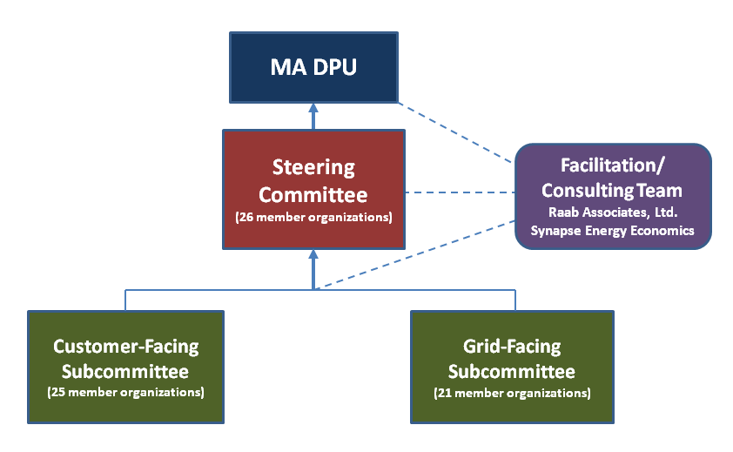
The Steering Committee was comprised of 26 member organizations from state government, consumer and environmental groups, the Distribution Companies and ISO New England, competitive suppliers, and representatives from a wide range of clean energy companies and organizations (see below in Table 1-1for Steering Committee Member Organizations). The DPU staff and a representative from the MA Executive Office of Energy and Environmental Affairs participated in the Steering Committee as ex officio Members. The two subcommittees were comprised of representatives from the Steering Committee Organizations and their affiliates, as well as additional organizations not directly on the Steering Committee. For a full listing of all the Steering Committee and Subcommittee Members and their representatives, see Appendix II.

Table 1-1: Steering Committee Member Organizations
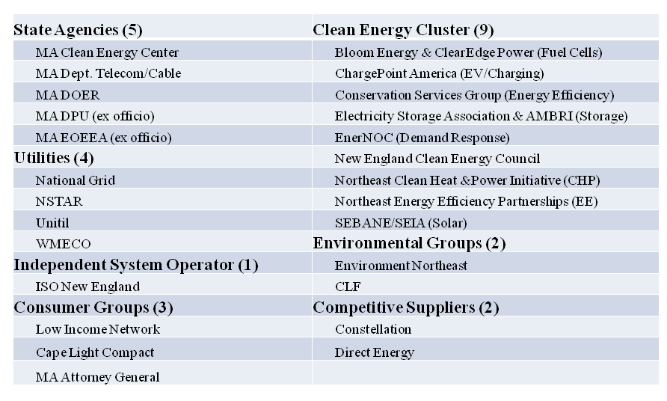
The Steering Committee had its first meeting in December 2012, and then met eight times altogether with its final meeting on June 17th of 2013. Each of the Subcommittees met three times between January and April 2013, to pull together pertinent background information on grid-facing and customer-facing technologies and practices currently in use, as well as possible alternatives moving forward. The Subcommittees also brainstormed potential principles and recommendations for the Steering Committee’s consideration and further development. The Steering Committee was responsible for completing the work begun by the Subcommittees, and also had the primary responsibility for addressing the issues that cut across both customer- and grid-facing strategies—such as regulatory policies (cost-effectiveness, cost-recovery), interoperability, and cyber-security. Figure 1-2 below shows the final constellation of meetings.

Figure I-2: Stakeholder Process Timeline and Meetings
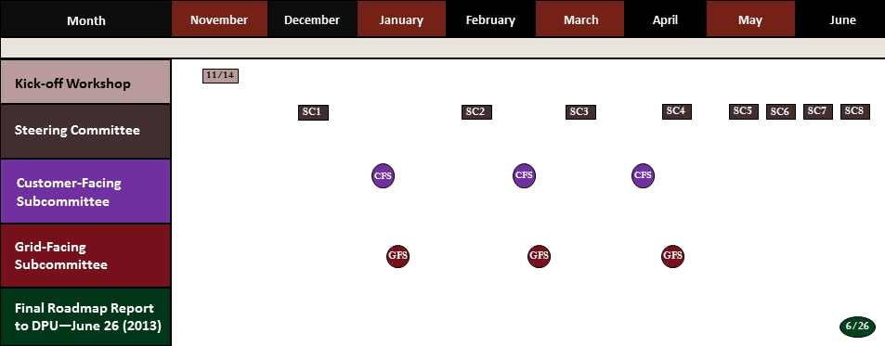
The working group stakeholder process was supported by a website where all of the agendas, meeting summaries, stakeholder groundrules, presentations, working documents, and a substantial library of background documents are all housed. The website also includes contact information for the members of the Steering Committee and both Subcommittees, as well as the schedule and location for all the meetings. The website will remain live and can be accessed at http://magrid.raabassociates.org/index.asp.
- Overview of the Report
The remainder of this Report contains a variety of work products and recommendations from the Steering Committee.
Chapter 2 of this Report includes the goals and opportunities for grid modernization specified in the Department’s NOI. It also includes a list of the potential barriers to grid modernization created by the current regulatory environment.
Chapter 3 includes a taxonomy of grid modernization for Massachusetts developed by the Grid-Facing Subcommittee and finalized by the Steering Committee, which includes the desired “outcomes” for grid modernization, as well as the activities, capabilities, and system enablers associated with those outcomes. The chapter also includes definitions for each of the terms used in the taxonomy.
Chapter 4 provides a brief summary and road map of the background information assembled largely by the Customer- and Grid-Facing Subcommittees or provided by the Distribution Companies. On the grid-facing side this background information provides some basic information about the describes the Massachusetts Distribution Companies’ current grid-facing system enabling technologies. On the customer-facing side, the background information includes high-level descriptions of the Distribution Companies’ current TVR pilot programs, as well as their current metering technologies. The customer-facing background information also includes information of the incremental capabilities (aka functionality) of a range of metering technologies, as well as the cost range for those metering technologies and related system enablers.
Chapter 5 provides the Steering Committee’s recommended principles related to over-arching, grid-facing, and customer-facing issues. Chapter 6 delineates the Steering Committee’s recommended regulatory policies including regulatory oversight, cost-effectiveness, ratemaking and cost recovery for grid modernization investments. Finally, in Chapter 7 the Steering Committee lays out its recommendations related to some potential next process steps for the DPU to take in this docket.
Please note that consistent with the Department’s NOI and the Steering Committee’s groundrules, any recommendations in this Report represent a consensus of all of the Steering Committee Members unless otherwise noted. Where a consensus was not reached by all of the Steering Committee members, two or more options are presented with a description of which Members support each option.
The appendices to this Report provide a additional information, and are referenced at the appropriate juncture in the body of the Report.

Chapter 2: Goals, Objectives, (and Barriers)

The Goals of Grid Modernization and the Working Group
To help establish regulatory policies and a road-map that will enable Massachusetts electric distribution companies, their customers, and other market actors to take advantage of grid modernization opportunities, both in the short-term and over the long-term.
Specifically, as specified in the NOI, to ensure that Massachusetts electric distribution companies, their customers, and other market actors adopt grid modernization technologies and practices to:
- enhance the reliability of electricity services; (NOI p.1)
- reduce electricity costs; (NOI p.1)
- empower customers to better manage their use of electricity; (NOI p.1)
- develop a more efficient electricity system; (NOI p.3) and
- promote clean energy resources. (NOI p.3)
Note that there may be tradeoffs in attempting to meet all these goals simultaneously, e.g., tradeoffs between enhanced reliability and reduced electricity costs.
- Grid Modernization Opportunities
The Department’s NOI identifies a number of grid modernization opportunities that the Stakeholder Working Group sought to evaluate and consider. The opportunities include:
- Reduce the frequency and duration of customer outages through automated, remote-controlled grid devices and real-time communication to the distribution companies of outages and infrastructure failures;
- Provide customers with the information, price structures, technologies, incentives, and tools that can empower them to use electricity more efficiently and reduce their individual energy costs;
- Improve the operational efficiency of the grid, particularly during peak times when the grid is most stressed and electricity is most expensive;
- Reduce transmission and distribution system operation, maintenance, and construction costs by reducing electricity demands at times of system peaks;
- Reduce New England wholesale and retail electricity costs by reducing electricity demand at times of system peaks;
- Facilitate the integration of distributed generation resources and new technologies, such as renewable energy technologies, combined heat and power, energy storage, fuel cells, and electric vehicles;
- Enhance the success of the Massachusetts energy efficiency and other clean energy initiatives, through the use of marketing campaigns and the advancement of technologies that both reduce peak demand and save energy;
- Reduce greenhouse gas emissions from the electric sector by: increasing the operational efficiency of the grid, reducing the need for the high emissions generating plants that run primarily during times of peak electricity demand; empowering customers to use energy more efficiently; and facilitating the integration of demand resources into the grid;

Barriers to Implementing Grid Modernization under Current Regulatory Practices

[AG proposed Intro.] The below list of barriers is a representative sample of the barriers and challenges voiced at the Kick-Off Workshop, at the first Steering Committee Meeting, and in the NOI. It does not represent an agreed to or all-inclusive list of barriers or concerns. The Stakeholder Working Group, however, sought to address these and other barriers that were identified during the course of the working group process.
- [AG Add] Grid modernization investments may be costly, and the ability to achieve, maintain and promote the affordability of electricity rates and charges for all customers is challenging;
- [Utility Suggest Delete] In order to take full advantage of prudent grid modernization opportunities, the Distribution Companies need to operate within a regulatory construct that [recognizes the increased risk associated with new and innovative technologies and programs and] aligns incentives to desired outcomes.
- [Utility Add] The Distribution Companies’ core responsibility to provide reliable and safe service to its customers may not be aligned with stakeholders’ positions and theories regarding grid modernization.
- [Utility Suggest Delete] Utility financial interests and incentives are not [del may not be] well aligned with the goal of taking full advantage of grid modernization opportunities
- Current regulatory policies do [del may] not provide Distribution Companies with sufficient direction regarding grid modernization investments. This is particularly true with regard to regulatory review, cost recovery, and TVR policies.
- [Utility Add] In order to take full advantage of prudent grid modernization opportunities, the Distribution Companies need to operate within a regulatory construct that recognizes the increased risk associated with new and innovative technologies and programs and aligns incentives to desired outcomes.
- Assessing the costs and benefits of grid modernization is challenging, and the framework has not been defined. Some of the benefits are difficult to quantify, monetize and verify, and some of the benefits and costs are experienced differently by different stakeholders. Also, a large portion of the costs may be experienced in the short-term while most of the benefits may not be experienced until well into the future.
- Balancing the benefits of increased reliability against increased costs is complicated
  - … and difficult to quantify [utilities]
  - …given the absence of clear guidelines for evaluating benefits and costs [CEC].
- Some customers may be at risk of experiencing higher costs without experiencing comparable benefits [CEC add] or having unaffordable rates or bills.
- The scope of the issues is broad and complex. There are many overlapping and inter-dependent issues to understand and assess. There are many different actors and stakeholders involved, many of whom do not coordinate on these issues.
- The pace of technological change, and the potential for technological obsolescence, increases the complexity of the issues.
- In order to obtain some of the benefits of grid modernization it will be important to engage customers: to respond to TVR, to install demand response and efficiency technologies, and to install distributed generation and storage technologies. Customer engagement and sustainability may be uncertain, may vary significantly across customers, and may be highly dependent upon the types of technologies and programs offered them.
- [CEC Add] Uncertainty as to the jurisdiction of the Department of Public Utilities over persons or corporations owning, controlling, operating, or managing facilities that supply electricity to the public to charge plug-in electric vehicles poses a barrier to private investment in plug-in electric vehicle charging infrastructure necessary to facilitate the widespread use of electricity as a transportation.

- [CEC Add]To obtain the benefits that electric vehicles can bring to the grid the DPU must address the proper role for regulated utilities in removing barriers to the widespread deployment of plug-in electric vehicles, minimizing adverse impacts associated with vehicle charging, and maximizing the environmental and system benefits of the use of electricity as a transportation fuel.

Chapter 3: Grid Modernization Taxonomy
- Taxonomy
One key objective of the Department’s inquiry into grid modernization is to consider the range of capabilities that collectively define a modern distribution network. To that end, the Department posed the following question for the Working Group in the NOI: “What are the key grid-facing technologies and practices that the distribution companies should be implementing to maximize the reliability and the efficiency of the grid?”
To answer this question, the Working Group set out to develop a grid modernization taxonomy that captures those capabilities or activities that could be most relevant to Massachusetts’ distribution companies. The taxonomy is included below in Figure 3-1. This effort drew upon a variety of resources, including the distribution companies’ investment plans and 3rd-party reports, such as the US Department of Energy’s assessments of Smart Grid Investment Grant projects funded by the Recovery Act of 2009.
[AG Proposed Caveat Language] This chapter is a result of the Working Group’s efforts. The chapter defines for the Department a range of potential capabilities, activities and enablers that may result in the Desired Potential Outcomes. In practice, the use of each potential capability and enabler may be dependent upon many factors under consideration and evaluation by the utility, consumer advocates, other stakeholders and the Department. The reader should not infer from this chapter that each Desired Potential Outcome and the associated capabilities, activities and enablers is equally valuable or necessary. This determination is dependent on the facts and circumstances of each case. Consequently, this chapter does not address issues such as cost recovery, cost-effectiveness, affordability, or the Department’s prudence and used and useful requirements for investments.
However, the Working Group was able to make substantial progress in identifying those outcomes, capabilities, activities and enablers that should be considered by the Department. The Working Group initially identified 14 core capabilities that could be deployed by Massachusetts distribution companies to support the grid modernization goals and opportunities highlighted in the Department’s Notice. The utilities are deploying many of these core capabilities already. See below for a complete list of capabilities and associated definitions. These capabilities were then grouped according to their primary desired purpose – or “Outcome” – to include the following:
- Reduce Impact of Outages. Measures that improve a Distribution Company’s ability to rapidly detect and respond to fault conditions on the network to reduce the duration and number of customers affected by an outage.
- Optimize Demand. Measures that are intended to encourage customer engagement in peak load reduction and enable load to be more fully utilized as a resource for distribution system planning and operations.
- Integrate Distributed Resources. Measures that enable a Distribution Company to safely and efficiently interconnect distributed generation and other variable resources to its network. These measures may also support utilization of such resources for system planning and operations.
- Workforce and Asset Management. Measures that improve a Distribution Company’s ability to monitor the location, performance and utilization of equipment and crews across its network.
In addition to the grid modernization capabilities and associated outcomes referenced above, the Working Group also recognized the Department’s desire to consider measures that could improve service reliability during storm events. These measures include a variety of activities, such as vegetation management and system hardening, which have long been utilized by distribution companies and are not unique to grid modernization initiatives. Accordingly, the Working Group created a separate outcome – “Prevent Outages” - to ensure the Department fully considers the range of Distribution Company investments that can support the goals and objectives included in the Notice:
- Prevent Outages. Measures that improve a Distribution Company’s ability to withstand severe weather events or other natural disturbances while maintaining service to customers.

Figure 3-1: Massachusetts Grid Modernization Taxonomy
Outcomes | Capabilities/Activities* | Network Systems Enablers
Reduce Impact of Outages | Fault Detection, Isolation and Restoration | • Communications  • SCADA / DMS  • OMS  • GIS
Reduce Impact of Outages | Automated Feeder Reconfiguration | • Communications  • SCADA / DMS  • OMS  • GIS
Reduce Impact of Outages | Intentional Islanding | • Communications  • SCADA / DMS  • OMS  • GIS
Optimize Demand | Volt/VAR Control, Conservation Voltage Reduction | • Communications  • SCADA / DMS  • Metering (enhanced AMR or AMI)  • Meter Data Management System  • Billing System
Optimize Demand | Load Control
Optimize Demand | HAN Capability
Optimize Demand | Advanced Load Forecasting
Optimize Demand | Time Varying Rates
Integrate Distributed Resources | Voltage Regulation | • Communications  • SCADA / DMS
Integrate Distributed Resources | Load Leveling and Shifting | • Communications  • SCADA / DMS
Integrate Distributed Resources | Remote Connect / Disconnect | • Communications  • SCADA / DMS
Workforce and Asset Management | Mobile Workforce Management | • Communications  • OMS  • GIS
Workforce and Asset Management | Mobile GIS | • Communications  • OMS  • GIS
Workforce and Asset Management | Remote Monitoring and Diagnostics | • Communications  • OMS  • GIS
Prevent Outages | System Hardening
Prevent Outages | Aging Infrastructure Replacement
Prevent Outages | Vegetation Management
* Note: Capabilities/Activities are connected here to their primary outcomes. Some Capabilities/Activities can also help facilitate other outcomes (see definitions).
The Working Group also sought to capture the core systems (e.g., metering) and enterprise software applications (e.g., outage management system) that underpin Distribution Company operations and support implementation of the various grid modernization capabilities. For example, a distribution company may require both Supervisory Control and Data Acquisition (SCADA) capabilities and a Distribution Management System (DMS) to implement automated feeder reconfiguration. These systems and software applications – collectively referred to as “Network System Enablers” – are included in the taxonomy alongside the relevant grid modernization capabilities.
Finally, whereas the Notice draws a distinction between “Grid-Facing Technologies” (e.g., those technologies that improve network performance) and “Customer-Facing Technologies” (e.g., those technologies that enable greater customer engagement), the Working Group sought to capture both categories within the taxonomy. This approach reflects the Working Group’s assessment that many of the Department’s goals and opportunities could best be pursued through a combination of grid-facing and customer-facing technologies. In fact, grid modernization investments around the country often feature the integration of grid-facing and customer-facing technologies to achieve desired outcomes.
- Definitions—Outcomes & Capabilities/Activities
Outcome 1: Reduce Impact of Outages
- Fault Detection, Isolation, Restoration (FDIR)
- Automated Feeder Reconfiguration
- Intentional Islanding
Fault Detection, Isolation, Restoration (FDIR)
FDIR is a collective term for the process of identifying the location of a fault condition on the system through the use of current and voltage monitoring devices; isolating the fault between two devices adjacent to the fault (e.g., opening two switches on either side of the fault); and, restoring service to the customers in the unaffected areas (i.e., not in the isolated section where the fault occurred). Next generation systems may use pre-programmed restoration scenarios that rapidly respond to equipment load ratings and real-time system load measurements. Such advanced applications require a robust, scalable two-way communications network. Although FDIR is sometimes referred to as a “self-healing grid,” it is important to note that the fault is not corrected until Distribution Company workers correct the cause of the fault – such as a downed wire - and return the affected section back into service.
Automated Feeder Reconfiguration
Automated feeder reconfiguration refers to the constant monitoring of the status of the distribution system (e.g. voltage and load conditions) and the ability of the system to respond by using alternate sources of supply to avoid an overload situation. Some FDIR systems also support automated feeder reconfiguration capability that enables restoration of service to the greatest number of customers possible through real time load monitoring.
Intentional Islanding (microgrid control)
An island condition is a situation where one or more generators are feeding an isolated section of the Distribution Company’s system. Intentional islanding control technology is used to isolate a specified section of the Distribution Company system from the rest of the grid (and its supply sources) such that the section is fed solely from local generation. This technology is also used to promote seamless reconnection of the islanded section to the larger grid. An unintentional island condition - in which a generator feeds into a fault on the grid - can pose a significant safety risk to Distribution Company employees and the general public because a line may remain energized without the Distribution Company’s knowledge.
Outcome 2: Optimize Demand
- Integrated Volt/VAR Control, Conservation Voltage Reduction
- Distribution Company /3rd party Demand Response Programs (load control)
- Home Area Network Communications Capability
- Advanced Load Forecasting
- Time Varying Pricing
Integrated Volt/VAR Control
Volt/VAR management is the term for technology that measures voltage and power factor on the distribution system and corrects imbalances to minimize power quality disturbances and limit line losses of the system. Next generation systems may include centralized processing with the ability to perform feeder-specific, substation-specific and area/region optimization. Future applications may also incorporate distributed solar photovoltaic (PV) cells and other resources through the use of controllable inverters for VAR support.
Conservation Voltage Reduction
Conservation voltage reduction refers to the active management of distribution voltage within a tight bandwidth to reduce energy consumptions and peak demand. Next generation systems may include centralized processing with the ability to perform feeder-specific, substation-specific and area/region optimization.
Distribution Company /3rd party Demand Response Programs (load control)
A load control demand response program is one where a signal is sent to a customer device (e.g., programmable controllable thermostats, water heaters, air conditioners) instructing that device to reduce electricity consumption. A two-way signal allows the sender of the signal to confirm whether the device has responded or the customer has decided to over-ride the signal. A load control program may be implemented by a Distribution Company or third party.
Home Area Network Communications Capability
A home area network (HAN) provides customers with access to usage data in more frequent time increments than once-monthly billing information. Retail pricing information may also be communicated to customers through a HAN. For example, a customer may program controls in the home to increase the set-point on the air conditioner in response to a critical peak signal sent from the Distribution Company. In order to connect a HAN to the customer’s meter, the meter must have a HAN communication module installed and activated. A HAN may also be installed by a customer for a variety of energy management purposes without requiring a connection to the meter.
Advanced Load Forecasting
Advanced load forecasting is the process of making more accurate and discrete predictions about future system loads based on customer usage data. Improved forecasts enable operators to better schedule and dispatch generation. Such forecasting may also include distributed generation and other resources, including demand response and electric vehicles.
Time Varying Rates
Time varying rates (also known as time of use rate structures) (TVR) changes the price customers pay based on time of day such that the rate is higher during periods of peak demand. At the most extreme, customers can pay a different price every hour based on wholesale market prices. In more traditional pricing structures, customers pay a different rate for a given number of hours every weekday, coincident with the time of system peak demand. Another form of time varying rates is a critical peak price or peak-time rebate that is typically implemented for a limited number of critical peak events when the system is constrained due to very high demand. A critical peak pricing program entails a higher price during critical peak periods, whereas a peak-time rebate provides customers with a credit or rebate for reducing usage during the same critical peak periods.
Outcome 3: Integrate Distributed Resources
- Voltage Regulation
- Load leveling and shifting (Intentional 2-way power flow)
- Remote Distributed Generation Connect/Disconnect & Monitor
Voltage Regulation
Advanced voltage regulation technologies may be used by Distribution Companies to manage fluctuations in voltage caused by large amounts of distributed generation relative to the amount of load in a given section of the Distribution Company system.
Load Leveling and Shifting (Intentional 2-way power flow)
Load leveling and shifting alters the pattern of demand to more closely match output from non-dispatchable, intermittent distributed resources such as solar PV. This technology may help mitigate reverse power flows and localized disturbances typically associated with high levels of intermittent distributed generation. Advanced applications may enable Distribution Companies to use distributed resources for system balancing operations. Such applications may include: on-site battery storage for active energy support; and voltage “ride through” capabilities that enable distributed generators to operate uninterrupted though grid disturbances.
Remote Distributed Generation Connect/Disconnect & Monitor
Remote disconnect is technology that enables a Distribution Company to use automation to remotely disconnect a distributed generation facility from the distribution system to protect safety or maintain service to other customers.
Outcome 4: Workforce and Asset Management
- Mobile Workforce Management Systems
- Mobile GIS Platforms
- Remote Monitoring & Diagnostics (equipment and system conditions)
Mobile Workforce Management Systems
Mobile workforce management systems provide Distribution Company field technicians with mobile access to asset records and other critical information in an effort to support timely and accurate assessments and services. These systems may also provide data useful to supervisors to plan, dispatch and monitor field services across a distribution company’s service area.
Mobile Geographic Information Systems Platforms
A Geospatial Information System (GIS) is the Distribution Company’s system of record for the as-built transmission and distribution network, providing a spatial view of assets and connectivity. Mobile GIS platforms allow Distribution Company technicians to download selected portions of the database to a laptop or other personal device for use in the field.
Remote Monitoring & Diagnostics (equipment conditions)
Remote monitoring and diagnostics enable Distribution Companies to collect more frequent data on the status of system equipment (e.g., oil samples from substation transformers). A Distribution Company may use these data to identify concerns (e.g., abnormal equipment performance), optimize day-to-day asset utilization and support condition-based maintenance programs.
Remote Monitoring & Diagnostics (system conditions)
Remote monitoring and diagnostics for system conditions consists of data collected via SCADA systems, to include voltage, loading, current, power factor and frequency. A Distribution Company may use these data to feed planning models, support advanced load forecasting and enable analytics that can improve and optimize system planning and operations.
Outcome 5: Prevent Outages
- System Hardening
- Aging Infrastructure Replacement
- Vegetation Management
System Hardening
System hardening refers to measures that are intended to make a Distribution Company’s assets better able to withstand a major storm or other catastrophic event. System hardening measures may include: elevated substations; equipment hardening; and distributed generation/storage.
Elevated Substations
Elevated substations are raised above ground-level to mitigate the risk of flooding during storm surges and other weather-related events. Such flooding can damage Distribution Company equipment and contribute to prolonged outages. Alternative approaches include relocating substations to less flood-prone areas or installing protective measures, such as pumps and levees.
Equipment Hardening
Equipment hardening refers to the replacement of existing Distribution Company infrastructure with equipment manufactured to more robust design standards and better able to withstand wind, water, ice and other elements. Examples include: installation of higher class poles and submersible equipment; installation of equipment with enhanced lightening protection; and replacement of bare wire with covered wire.
Distributed Generation/Storage (still under discussion)
Distributed generation and storage include those resources located close to load centers, such as neighborhoods, offices parks and industrial facilities. Distributed resources can harden the grid by providing uninterrupted power to critical facilities and supporting expedited power restoration during unplanned outages.
“ [Malkin possible alternative from US EIA] A generator that is located close to the particular load that it is intended to serve. General, but non-exclusive, characteristics of these generators include: an operating strategy that supports the served load; and interconnection to a distribution or sub-transmission system (138 kV or less).
[Utility Suggested Alternative] Distributed generation and storage include those resources located close to load centers, such as neighborhoods, offices parks and industrial facilities. Distributed resources interconnected consistent with Distribution Company protocols may be able to harden the grid by providing uninterrupted power to critical facilities and supporting expedited power restoration during unplanned outages. In addition, while distribution resources may be able to harden the grid by providing uninterrupted power to critical facilities, careful consideration must be given to safety concerns in order to provide adequate protection for Distribution Company employees and the general public.
Aging Infrastructure Replacement
Replacement of infrastructure that is prone to failure due to age with equipment that meets current design specifications. An example is the replacement of paper insulated lead cable with Ethyl-Propylene Rubber (EPR) insulated cable.
Vegetation Management
Vegetation management entails a series of Distribution Company -sponsored measures to reduce the frequency of faults caused by trees and other vegetation coming into contact with overhead power lines. Vegetation management may include: tree pruning and removal; vegetation control around poles, substations, and other electric facilities; manual, mechanical, or chemical control of vegetation along rights-of-way; tree inventories; and other related activities.
- Network Systems Enablers
- Distribution Management System (DMS)/SCADA
- Outage Management System (OMS)
- Geospatial Information System (GIS)
- Billing System
- Metering System
- Meter Data Management System (MDMS)
- Communication Systems (Fiber, Microwave, Radio, etc.)
Distribution Management System (DMS)/SCADA
A DMS is a computer system used by a Distribution Company to receive data from devices deployed at various locations on the network that are equipped with supervisory control and data acquisition (SCADA) technology to provide operators with a real-time picture of the status of the distribution system. Using the DMS, operators can control devices to isolate faults and restore unaffected sections of the system. Advanced capabilities of the DMS enable automatic operations in response to current conditions (e.g., fault conditions, volt/VAR optimization and feeder reconfiguration in response to load). Although it is often assumed that a DMS will be deployed on a system-wide basis, it can also work at a substation or feeder level when appropriate.
Outage Management System (OMS)
An OMS is a computer system used by a Distribution Company to collect data on the location of outages on the system and the number of customers affected. Customer calls reporting loss of service are represented in the OMS which then uses software-based rules to identify the likely source location for the outage. In larger scale events with multiple simultaneous outages, the OMS is used by the Distribution Company to prioritize restoration efforts by focusing on outages affecting the greatest number of customers. As power is restored, the OMS is updated based on field reports ensuring an accurate representation of remaining problems. A Distribution Company’s OMS may be integrated with a DMS and/or metering system.
Geospatial Information System (GIS)
A GIS is a computer system that provides a graphical representation of the distribution system. The GIS system may include the asset location of major Distribution Company equipment such as substations, switches, transformers and poles. Detailed asset information (manufacturer, installation date, size, etc.) is also stored along with the location data. The GIS is typically the single source or repository of asset information that feeds system planning models, system operations models, outage management models and work-order/financial systems. Advanced features may include system mapping and design modules. A Distribution Company may also integrate its GIS and OMS systems to allow for reported outages to be mapped on the GIS system for an accurate location of the device (e.g. fuse or switch) that the OMS calculates as most likely to be at the source of the outage.
Billing System
A Distribution Company’s billing system creates a customer bill by applying a customer’s electricity usage for a given period to the customer’s rate structure. The billing system typically works together with a customer information system as the system of record documenting address, contact information, payment history and special status (e.g., life support customer).
Metering System
The Distribution Company’s metering system is the collective term for the customer meters that measure electricity usage and the communications method used to transmit usage data back to a meter data management system. Electricity meters measure usage for a given period of time from every 5 minutes to monthly and in some cases measure peak demand for a period. The communications infrastructure may range from manual reading on a hand-held device downloaded at a central location to two-way cellular or radio signals sent every 15 minutes that will support advanced features such as dynamic rate structures, demand response programs and outage management. A Distribution Company may integrate its metering system and OMS to allow for outage data to be recorded in the OMS based on the status of each customer’s meter rather than as a result of customer phone calls.
Meter Data Management System (MDMS)
An MDMS is a computer system that takes raw usage data and processes it into a form that can be used for billing. For instance, an MDMS can take hourly usage data for a month and categorize the hours into on and off-peak periods that can be sent to the billing system to create a time of use bill. In some instances, a Distribution Company’s billing system is capable of serving as its MDMS as well. An MDMS also facilitates the delivery of advanced metering features, such as dynamic rates, demand response programs and outage management.
Communications Systems (Fiber, Microwave, Radio, etc.)
Communication systems are used in many Distribution Company operations. Voice communication systems (e.g., radio or cellular) enable the work force to communicate on a real-time basis. Data communication is used for collecting information on distribution system status from SCADA devices and metering systems to transmit usage data from meters to an MDMS. Data communication is also used as a means to remotely control devices in the field. Key factors for selecting next generation communications systems include but are not limited to adherence to industry standards (i.e., NIST), bandwidth, service quality and scalability to the customer level, each of which is important to achieving a safe, secure, reliable and flexible communications network.

Chapter 4: Background Information and Joint Fact Finding Road-Map (or could be Appendix X?) [Note: Links are not live but will be added in final report]

A) Grid-Facing
The Grid-Facing Committee asked the Distribution Companies two sets of questions regarding the status of the existing grid-facing infrastructure. The purpose of these questions was to provide an indication as the extent to which the Distribution Companies have adopted grid modernization capabilities and network system enablers (see Figure 3.1).
The first set of questions was intended to get descriptions; installation dates; the levels of deployment of various technologies; and additional characteristics of the various network system enablers. The second set of questions was focused on the Distribution Companies’ current capabilities for integrating distributed generation onto their systems; including information regarding the measurement/estimation of minimum load, equipment to readily integrate distributed generation resources, and additional relevant data. The questions asked, and the Distribution Companies responses to them are available HERE.
The responses to the first set of questions are summarized below in Tables 4-A1, 4-A2, and 4-A3. Table 4-A1 provides an overview of the substations, feeders and capacitors that are currently installed on the utility systems. For each utility, and for each technology type, the table presents the total number, the number of automated technologies, and the percent of the total that is automated. This table also provides some definitions of the different technology categories.
Table 4-A2 provides more details, including the types of network system capabilities (e.g., fault detection, integrated volt/VAR control, remote monitoring) that are located on each utility system. This includes information on the level of the system at which the capabilities are located, including transmission system level, distribution system level, substation level or neither.
Table 4-A3 provides additional details for the network system enablers. This includes when they were installed, status of recent upgrades, and future plans for upgrades.
Based on the responses to the first set of grid facing questions, the Distribution Companies were asked to respond to a second set of grid-facing questions. The first question of this second set asked for the percentage of substations, feeders and line sections where each Distribution Company was able to directly measure minimum load. The second question asked each Distribution Company to provide the number of substation transformers and voltage regulators capable of reverse power flow. Finally, the third question gave each Distribution Company the opportunity to provide any additional data or descriptions that would further explain their deployment of modern grid technologies.

The utilities’ responses to the second set of grid-facing questions are summarized in the tables below. Table 4-A4 shows the percentage of each utility’s system with the ability to measure minimum load. Table 4-A5 shows the percentage of each utility’s systems that are capable of reverse power flow.
Note that the utilities’ responses to these questions include some important notes with more detail on the information in these tables. In addition, the responses include additional information and explanation about the deployment of technologies on the distribution system, beyond what could be summarized here. The complete responses from the utilities can be found HERE.

Table 4-A4. Percentage of Systems With the Ability to Measure Minimum Load
 |  | Substations | Feeders | Line Sections
National Grid |  | 52% | 50% | 27%
NSTAR | North 115/14kV Stations | 100% | 100% | -
NSTAR | North 4kV Stations | 80% | 84% | -
NSTAR | South 115/23kV and 115/13.2kV Stations | 100% | 100%
NSTAR | South 4kV Stations | 5% | 5% | -
NSTAR | North and South 15kv Line Sectionalizing Devices | - | - | 93%
NSTAR | North and South 4kv Line Sectionalizing Devices | - | - | 100%
Unitil |  | 30% | 37% | 0%
WMECO |  | 70% | 36% | 21%

Table 4-A5. Percentage of Systems Capable of Reverse Power Flow
 | Substation Transformers | Substation Regulation | Feeder Regulation
National Grid | Reverse power flow issues regarding DG installation can potentially be addressed on an on-going basis as technologies and operational knowledge matures. | No count available. Percentage is relatively low. New controls have bidirectional capability. | No count available. Percentage is relatively low. New controls have bidirectional capability.
NSTAR | Systems designed for forward power flow. Little experience to date with reverse flow. | Roughly 50%. | Roughly 50%.
Unitil | No substation transformers currently designed for reverse power flow. | No count available. Percentage is relatively low. New controls have bidirectional capability. | No count available. Percentage is relatively low. New controls have bidirectional capability.
WMECO | Systems designed for forward power flow. Little experience to date with reverse flow. | Roughly 50%. | Roughly 50%.

Table 4-A1

 | Substations1 |  |  | Feeders2 |  |  | Capacitors3
 | Total | Automated | Percentage | Total | Automated | Percentage | Total | SCADA Control | Percentage | Automated  Response | Percentage
NSTAR | 200 | 120 | 60% | 1579 | 995 | 63% | 830 | 640 | 77% | 95 | 11%
WMECo | 28 | 10 | 36% | 233 | 134 | 58% | 250 | 62 | 25% | 77 | 31%
National Grid | 258 | 138 | 53% | 1028 | 567 | 55% | 2500 | 0 | 0% | 1800 | 72%
Unitil | 11 | 4 | 36% | 36 | 14 | 39% | 135 | 0 | 0% | 40 | 30%

Category  Definitions | 1 Substation automation is defined as the full SCADA integration (status, control and analog data) of the substation for all major equipment (power transformers, substation capacitors and breakers/reclosers). This may or may not include  the power transformer LTC and/or individual phase regulators for distribution feeders.  In some cases partially automated substations (portion of a substation is fully automated without all distribution feeders being fully automated) have been included in the count (a very small percentage of feeders are in this category). "Full" automation does not typically include feeder phase regulators but does include LTC automation for new installations. | 2 Feeder automation is defined as the full SCADA integration (status, control and analog data) of the feeder breaker/recloser within the substation fence and/or the SCADA control of automatic sectionalizing devices outside the substation fence on the distribution feeder. Additionally non- communication enabled automated loop sectionalizing schemes and/or preferred/alternate schemes have been included as well as more advanced multi-switch/multi-feeder communicating FDIR schemes. These figures include both overhead and underground feeders | 3 Capacitor counts included in this table are line banks only, not substation banks.  SCADA control is defined as the ability to send a signal to remotely operate the bank and may or may not include status of the bank.  Automated response is defined as the presence of a local control capable of operating the bank programmatically based on time, day, date, temperature and/or power quantity values (voltage, current, KW flow, KVAR flow, etc.).

Table 4-A2

NSTAR
System Location Notes
Fault Detection, Isolation, Restoration (FDIR) | Distribution system and substations | 80 auto reconfiguration loops, with 100 additional planned for 2013
Automated Feeder Reconfiguration | Distribution system and substations | FDIR devices continuously monitor system, alerting operators of loading concerns.
Integrated Volt/VAR Control, Conservation Voltage  Reduction | Transmission, distribution, substations | 830 Capacitor bank, of which 640 are controllable remotely. No CVR.
Remote Monitoring & Diagnostics ( equipment conditions) | Transmission, distribution, substations | All major equipment is remotely monitored via SCADA i.e. Substation transformers, remote controlled switches, communications, etc..
Remote Monitoring & Diagnostics (system conditions) | Transmission, distribution, substations | All remote controlled reclosers and ASUs monitor the system providing voltage, current and power factor.

WMECo
System Location Notes
Fault Detection, Isolation, Restoration (FDIR) | Distribution system | 120 recloser loop schemes on its system. All loop schemes operate automatically in response to loss of source voltage.
Automated Feeder Reconfiguration | None
Integrated Volt/VAR Control, Conservation Voltage  Reduction | Distribution system and substations | Manage voltage within a +/- 5% bandwidth, no CVR
Remote Monitoring & Diagnostics ( equipment conditions) | Substation | Alarms alert operators for various abnormal conditions. No capability to remotely sense specific equipment conditions (e.g. oil levels) or diagnose problems.
Remote Monitoring & Diagnostics (system conditions) | Distribution system and substations | DSCADA for remote monitoring and diagnostics of system conditions.

Unitil
System Location Notes
Fault Detection, Isolation, Restoration (FDIR) | Distribution system | One circuit currently has FDIR recloser combination
Automated Feeder Reconfiguration | None
Integrated Volt/VAR Control, Conservation Voltage  Reduction | Distribution system and substations | Manage localized circuit level power factor and voltage through the use of capacitor banks that are automatically controlled based on system condition or time of day.
Remote Monitoring & Diagnostics ( equipment conditions) | None
Remote Monitoring & Diagnostics (system conditions) | Distribution system and substations | SCADA is installed in 4 of 11 substations. This includes remote monitoring on 4 capacitor banks, approximately 45 breakers/reclosers, and 6 transformers.

National Grid
System Location Notes
Fault Detection, Isolation, Restoration (FDIR) | Distribution system | Approximately XX non-communicating or communicating loop sectionalizing schemes and/or preferred/alternative schemes  Small rollout of Advanced Distribution Automation (multi-switch/multi- feeder communicating system) as part of SG pilot
Automated Feeder Reconfiguration | None
Integrated Volt/VAR Control, Conservation Voltage  Reduction | Distribution system | Advanced Local Volt/Var Control: Small rollout as part of SG pilot  2.5/5% voltage reduction on 75% of feeders per NE-ISO operating procedures
Remote Monitoring & Diagnostics ( equipment conditions) | Transmission, distribution, substations | A small subset of large power transformers have remote condition monitoring via SCADA, additionally SCADA alarms alert operators of various abnormal conditions on a wider range of distribution and transmission equipment. A small rollout of devices as part of the SG pilot will provide equipment monitoring on all new devices.
Remote Monitoring & Diagnostics (system conditions) | Transmission, distribution, substations | SCADA for remote monitoring and diagnostics of system conditions within the substation fence. Also remote controlled reclosers monitor the system providing voltage, current and power factor. A small rollout of new equipment as part of the SG pilot will provide near real time monitoring of system conditions at several locations on the pilot feeders.

Table 4-A3

Type When Installed Most Recent Upgrade Future Plans Notes
NSTAR
Distribution Management System (DMS)/SCADA
GE SCADA/EMS: Trans, Sub-trans, North Distribution 1994 2007 Migrate and implement auto-restoration schemes 1,100+ supervisory, and 60,000+ analog & digital points
GE Powerlink Advantage: South Distribution 2005 2011 750+ supervisory, and 40,000 analog & digital points.
Outage Management System (OMS) CGI PragmaLine v2.03 2000 Replaced
GATOR 2003 Planned replacement 2013-2014
Geospatial Information System (GIS) Editor: Custom ESRI North: 1990s, South: 2004 Upgrade in progress
Viewer: ESRI ArcMap with customization 2004 Upgrade in progress
Transmission Editor: ArcFM 2008 Upgrade in progress
GIS-OMS Integration GATOR-GUI 2003 (within OMS upgrade) GIS upgrade in progress OMS Replacement 2013-2014
Billing System
1991 Continuous
Metering System Premierplus4 ? Replaced
FCS (Field Collection System) 2012 Underway
Route Smart ArcGIS 2007 2011
MV90 (Interval Meter Collection) 2006 2009 Upgrade in 2013 for 7000 TOU meters via modem and cellular networks
Meter Data Management System (MDM) Lodestar 2011
OMS-AMR/AMI Integration N/A N/A
Communication Systems Various systems 2008-2010

Type When Installed Upgrades Future Plans Notes
WMECO
Distribution Management System (DMS)/SCADA
Siemens Spectrum Power TG 2002 currently upgrading 2400+ devices, 280,000+ analog & digital points.
Outage Management System (OMS) Oracle Network Management System 2004 2007 upgrade/replacement in 2014
Geospatial Information System (GIS) Editor: GE Smallworld Editor 2002 2008
Viewer: GE SIAS Viewer 2010
Transmission Editor N/A N/A Integration into Smallworld editor around 2013
Viewer: ESRI SilverLight Viewer - custom 2012
GIS-OMS Integration Smallworld 2004 2008 replacement in 2014
Billing System C2 Application 2008 Continuous
Metering System Fieldnet 1990s 2012 Upgrade in 2014
Prime Read (Interval Meter Collection) 2008 Move all to MV90 and retire application
ION Revenue 2005 Move all to MV90 and retire application
Meter Data Management System (MDM) Lodestar MDM 2013
SerViewCom ? 2010 Move all to MV90 and retire application
EVEE Meter Data Warehouse 2003 2012
OMS-AMR/AMI Integration N/A N/A
Communication Systems Fiber 2005-2013
Microwave 2005-2013 Some will be replaced by fiber, where appropriate
Mobile Radio 2005-2008
DSCADA Radios 2012-2013

Type When Installed Upgrades Future Plans Notes
National Grid
Distribution Management System (DMS)/SCADA
None N/A N/A Planned OMS and EMS SCADA interface after OMS installation in fall 2013 to support potential future DMS
Outage Management System (OMS) PowerOn 2006 PowerOn to be replaced with ABB OMS as part of EMS upgrade during fall of 2013
Geospatial Information System (GIS) GE Smallworld 2004 2011 Currently using latest version (V4.2), no upgrade plans for a least three years. T Current GIS is integrated with OMS and WMS
GIS-OMS Integration Fully Integrated - GE Smallworld/PowerOn 2006 PowerOn to be replaced with ABB OMS as part of EMS upgrade during fall of 2013
Billing System Customer Service System (CSS) 2008 Integration of SG Pilot meter data
Metering System
Solid State (22%) around 2000 2012 none planned, but Smart Grid Pilot underway .297 million meters. 92% of all National Grid meters read via Drive-by AMR

B) Time-Varying Rates
Time varying rates (TVR aka dynamic pricing) issues and experience in the U.S. and abroad were presented by the Brattle Group at the Kick-Off Summit (See Brattle Presentation HERE 11/14/12). The Customer-Facing Subcommittee then heard detailed presentations regarding the smart grid pilots from NSTAR, NGRID, and UNITIL at its first meeting (See Utility Presentations Here 1/9/13), and the Steering Committee heard an updated presentation on NSTAR’s pilot at its 6th meeting (See NSTAR/Navigant Presentation HERE 5/22/13). At the second Customer-Facing Subcommittee meeting, the Regulatory Assistance Project presented additional information on experience and issues in the U.S. and abroad on TVR, and the Attorney General’s consultant presented both the principles developed by NASUCA et al on consumer protections related to TVR and AMI as well as additional recent experience across the U.S. on TVR and AMI (See RAP and AG presentations HERE 2/26/13). Finally, at the 5th Steering Committee the Attorney General presented some research it had done on TVR in other restructured states (See Basic Service Memo & AG TVR Table HERE 5/14/13). The following tables and graphs extract some of the summary tables and highlights from these presentations; however, please see the actual presentations and the meeting summaries from the meetings in which the documents were presented and discussed for the full details.
Current rates for basic service residential and small commercial customers of Massachusetts investor-owned Distribution Companies are essentially a flat rate that does not vary by time of day, day of the week, or by season. In this regard, Massachusetts is typical of other retail restructuring states where a default service is provided to residential and small commercial customers pursuant to wholesale market contracts that are intended to reduce price volatility.
Time varying rates are rates that have some variability based on when energy is consumed and generally reflect shorter term wholesale market prices. As Table B1-X illustrates there is a continuum of ways to design rates to make them more or less reflective of the frequency of changes in price at the wholesale level. These range from time-of-use (TOU) rates that divide the day into two or three time periods with different rates that are then fixed for a season or a year, up to real-time pricing (RTP) where prices can change hourly to reflect wholesale pricing conditions. Critical peak pricing (CPP) is generally an overlay on TOU pricing that allows for prices to rise significantly at pre-announced times when costs are projected to rise significantly. Peak time rebates (PTR) is an alternative TVR approach where customers are given a rebate for reducing load generally during critical peak periods.
Table 4-B1: Rate Continuum: Static to Dynamic 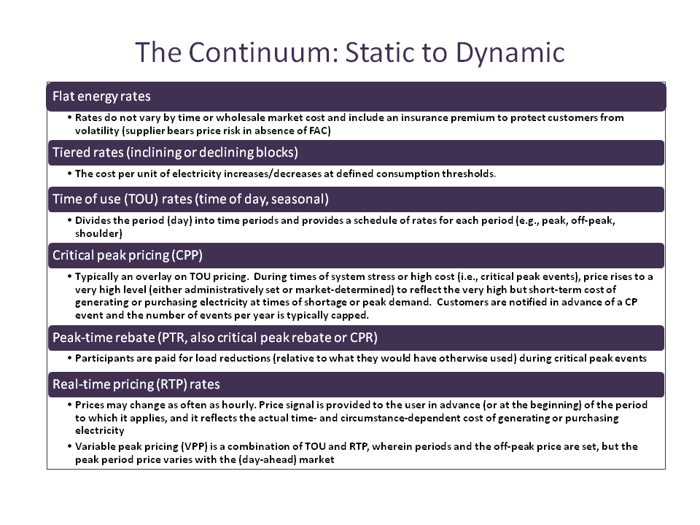
Figure 4-B1 shows a depiction of the range of TVR options and how the potential reward (defined in this chart as the discount from flat rate) compares to the risk (variance in price). The chart shows that real-time pricing (RTP—generally hourly pricing) potentially has the highest reward for customers but also has the highest risk. Time-of-using pricing (TOU) on the other hand has a much lower potential reward but also a much lower risk—with CPP falling between the two. Peak-time-rebates (PT) by contrast, provide a reward (in the form of a rebate) but no real risk (since you only get a rebate when you reduce, but are not penalized if you do nothing).
Figure 4-B1: Risk-Reward Tradeoff in Time-Varying Rates
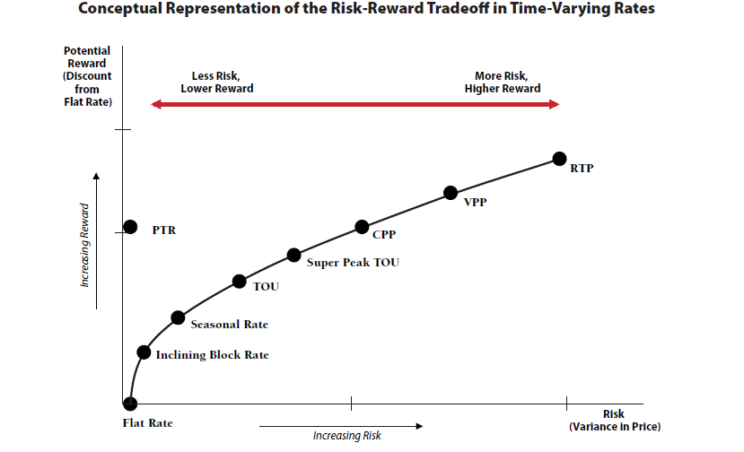

Figure 4-B2, presented by Brattle and by RAP, is a graph of the peak reduction and the peak to off-peak price reduction from 74 TVR pilot programs across the U.S. It illustrates two points. First, higher peak to off-peak price ratios (whether reflected in CPP or PTR) generally elicit higher responses in the form of peak reductions than lower ratios. Second, TVR associated with enabling technology that facilitates load management actions generally increases the peak reduction response. It should be noted that this tables presents analysis of various pilot results which may not be indicative of wide scale deployment. According to a recent Navigant study, adoption rates of TVR in many cases remains low once scaled beyond pilot scope (see 5/22/13 Navigant presentation

Figure 4-B2: Peak Reduction Relationships to Price Ratio & Enabling Technology
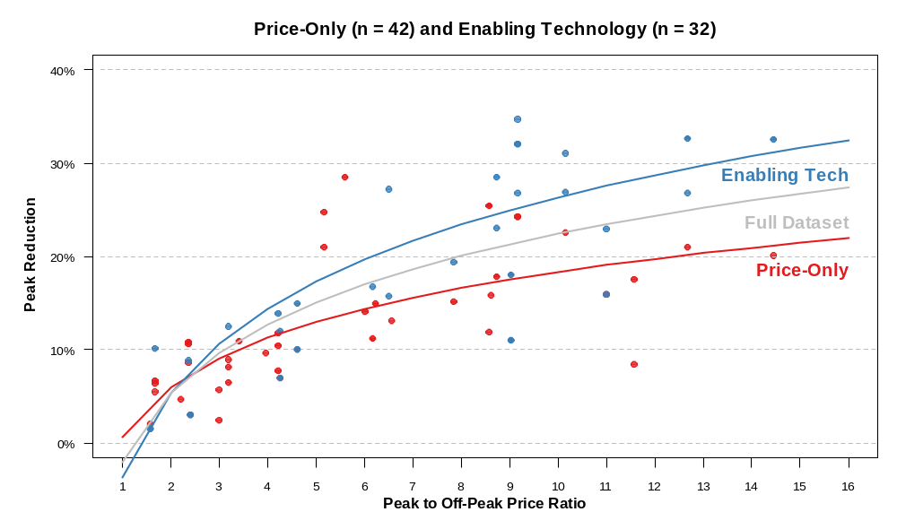

The Massachusetts distribution companies are in various stages of completing their smart grid pilots, which are testing a range of TVR rates as well various metering and other enabling technologies.
Unitil, which already had installed an early AMI metering for all its customers, has completed their pilot. Unitil used a TOU rate with and without enhanced technology and smart thermostats. They found kw reductions with the TOU without enhanced technology of 21% on-peak and 42% during the critical peak period. The savings with the enhanced technology added increased to 35% for on-peak and 70% during the critical peak. The customer bill savings averaged 5% for the simple TOU and 7% with the enhanced technology.
Table 4-B2: Unitil’s Smart Grid Pilot Results
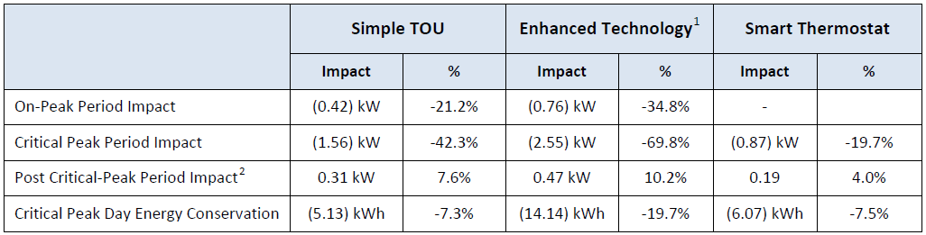
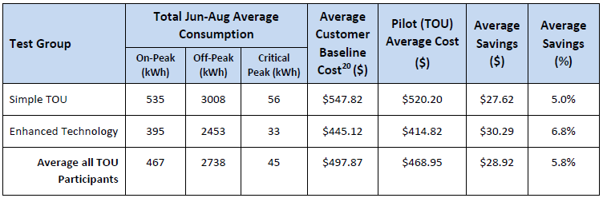
NSTAR is still in the middle of its pilot, which is scheduled to be completed at the end of 2013. NSTAR is using its pre-existing AMR meters enhanced with home area networks for its pilot. As Table 4-B3 describes, NSTAR is testing 3 different TVR approaches (PTR with NSTAR control of a smart thermostat, and TOU with CPP with and without enabling technology), plus a group that will receive enhanced information but stay on their otherwise applicable rates. Figure 4-B3 below shows the interim peak savings during both the summer and winter for all 4 groups of participants. NSTAR presented the results of the first 9 months of its 24-month pilot from an evaluation report completed by Navigant in March 2013. The 3 TVR groups appear to have saved more kw during both the summer and winter peak periods than the enhanced information group—but there doesn’t appear to be a clear winner among the two TOU options and the PTR option in terms of which performed better overall in terms of kw reduction in both the winter and summer seasons.
Figure 4-B4 below provides a summary to show the customer evolution from the number of customers contacted, to installed, and finally the number currently enrolled—including the significant drop-out rate at each stage. The final evaluation and numbers on this pilot should be available in the spring of 2014.
Table 4-B3 NSTAR’s Smart Grid Pilot Customer Test Groups
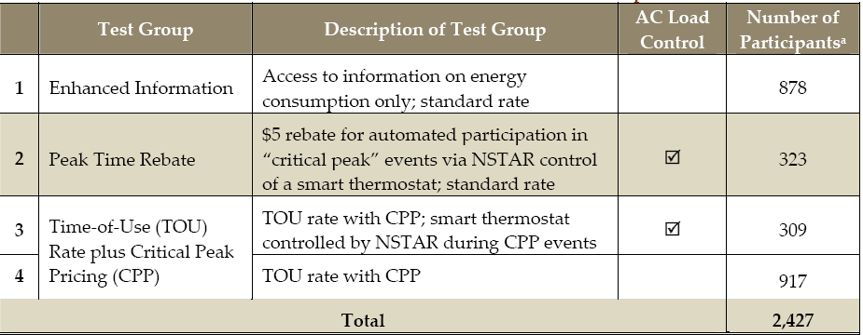

Figure 4-B3 NSTAR’s Average Peak Period Load Reductions (January-September 2012)
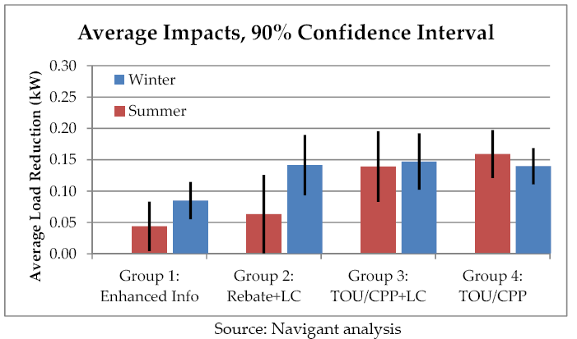

Figure 4-B4
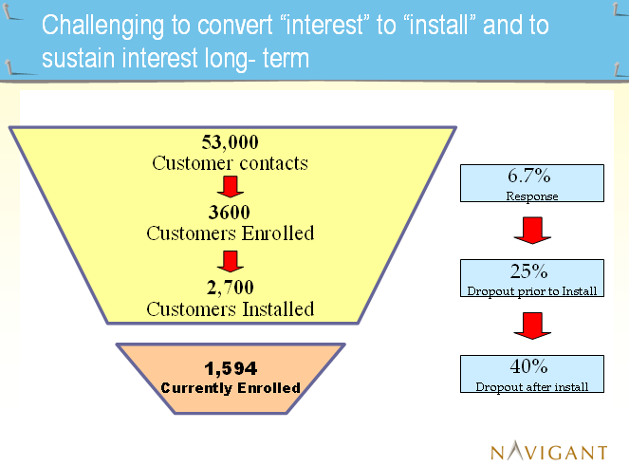
National Grid is just in the process of rolling out its smart grid pilot in Worcester, so no data is available yet except their approved design and initial experience with meter installation. Although NGRID already has AMR meters, it is planning on installing 15,000 AMI meters for the pilot participants. It will offer three different TVR options to its customers: 1) CPP for residential and small C&I; 2) PTR option also for residential and small C&I; and 3) HPP—hourly pricing for largest C&I customers. Unlike the other pilots, National Grid’s pilot is designed as an “opt out” experiment. The utility will enroll customers in the default CPP rate but allow customers to opt out of that rate and either leave the pilot entirely or select a PTR option.

As Figure 4-B5 shows there will also be various combinations of technology options (home display units, smart thermostats and automatic HVAC controls, and load control devices.) Meter completion was scheduled for May 31, 2014 and the pilot TVR pricing starts January 1, 2014.
Figure 4-B5: National Grid’s Smart Grid Pilot 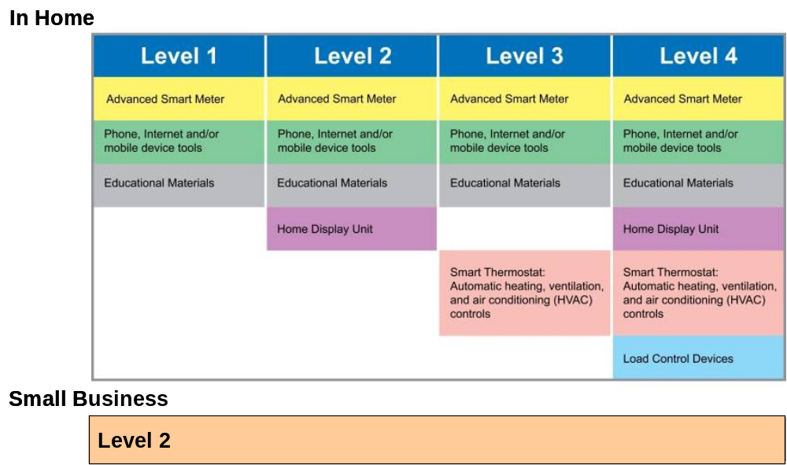

As Figure 4-B5 describes, the Massachusetts Distribution Companies currently have mandatory TOU rates (distribution portion only) for their largest C&I customers. However, for residential and small C&I customers there are legacy optional TOU rates that have been in place for some time but are not marketed or well-subscribed by customers, as outlined in Figure 4-B6: Legacy Massachusetts Distribution Companies TOU Rates.
Figure 4-B6: Legacy Massachusetts Distribution Companies TOU Rates 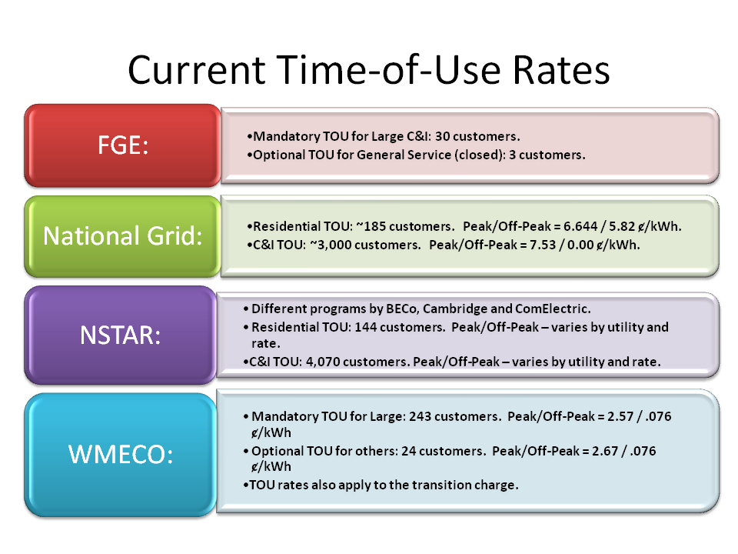

Table 4-B4 is a summary of research done by the Attorney General’s Office on the use of TVR by other restructured states. It found that in each of the states basic service is a flat rate, with a range of TOU and PTR rates that are available on a voluntary opt-in basis.
Table 4-B4: TVR and Metering in Other Restructured States
State/Utility | Type of Metering Prior To AMI (Manual Read, AMR) | Type of Metering (AMI, AMR, or Enhanced AMR) | Basic Service Design | Type of TVR (TOU, TOU/CPP, or PTR) | On Basic/Default Service (supply) Distribution Rates, or Both |  | Opt-In, Opt-Out, or Mandatory
Connecticut |  | Not AMI | Flat Rate | Legacy TOU | Supply Only |  | Opt in
Delaware | Manual Read | AMI | Flat Rate | TOU legacy and PTR | Both |  | Large scale PTR pilot underway; participation is opt in
District of Columbia* | Manual Read | AMI | Flat Rate | TOU legacy | Supply Only |  | Opt in
Illinois | Various | AMI (over 10 years) | Flat Rate | "Real Time" Pricing since 2009; Legacy TOU; PTR in future | Supply Only |  | Opt in
Maine* | Manual Read | AMI - CMP | Flat Rate | TOU | Supply Only |  | Opt in
Maryland* | Manual Read | AMI being installed | Flat Rate | Legacy TOU and PTR | Both |  | Overlay on Basic; participation is opt in
Michigan* | Manual Read | AMI (over 10 years) | Flat Rate | TOU | Supply Only |  | Opt in
New Hampshire |  | Not AMI | Flat Rate | TOU legacy | Distribution Only |  | Opt in
New Jersey |  | Not AMI | Flat Rate | TOU legacy | Both |  | Opt in
New York |  | Various; not AMI | Flat Rate | TOU legacy | Both |  | Opt in
Ohio* | Various | AMI only for Duke and AEP | Flat Rate | TOU legacy; pilot TOU for AMI | Supply Only |  | Opt in
Pennsylvania* | Various | AMI (over 10 years) | Flat Rate | TOU with installed AMI; PTR for one utility | Supply Only |  | Opt In
Rhode Island |  | Not AMI | Flat Rate | None | NA |  | NA
Texas* | Various | AMI | None | Unknown | Unknown |  | Opt in
Notes:
1. This information reflects residential rates only.
2. Several of these Distribution Companies offer optional EV charging TOU rate with or without AMI
3. In these states, licensed suppliers can offer TVR but these rate options are not typical of most offers
* means that one or more Distribution Companies in these states received ARRA funding for up to half of the AMI deployment costs
4. Original spreadsheet also includes description of any TVR or PTR, and whether administered by utility or another (see original on the website at Steering Committee Meeting # 5)
Source: Office of the Attorney General

C) Metering

Metering issues and discussion permeated numerous Steering Committee meetings, as well as both Customer-Facing and Grid-Facing Subcommittee meetings. There were three different pieces of meter-related work overseen primarily by the Customer-Facing Subcommittee to help the Members garner a better understanding of the current metering infrastructure in Massachusetts.
- The Distribution Companies were asked to reply to three sets of data requests to provide information as to their current metering infrastructure and replacement protocols (See: 1) the first set of NU, NGRID, & Unitil Metering Questions HERE 2/26/13; 2)the Compilation of Metering Responses HERE 4/4/13; 3) the second set of utility metering responses and update compilation HERE and; 4) the third set of utility metering responses HERE .
- Three meter-related hardware and software vendors provided the Steering Committee with presentations which focused on options for enhancing metering infrastructure, including types of technology, functionality, and cost (See presentations by Itron, AvCom, and Sentinel Works HERE 1/9/13).
- Lastly, the Customer-Facing Subcommittee and a metering working group that was formed to assist the Subcommittee, spent a substantial amount of time reviewing and analyzing various metering technology options and the manner in which those technologies could support a range of customer-facing and grid-facing capabilities and functions. As part of this review and analysis, the Subcommittee and working group identified the incremental functionality of various technologies. The Subcommittee and working group also worked to develop cost ranges for the various technologies, including the meter cost, installation, and a range of necessary supporting infrastructure. The cost data was initially supplied by ITRON (Itron, HERE 1/9/13 and in subsequent discussions with working group and Subcommittee), and was then adjusted by the Distribution Companies based on their own distribution systems and experience gained from the pilots to date (See Metering Technologies Functions Costs spreadsheet with the various worksheets HERE 4/23).

The Massachusetts Distribution Companies, with the exception of Unitil, all converted their meters from manual-read meters to AMR meters during the 1990’s through the last decade. AMR meters are read from a moving vehicle rather than by a meter reader. Unitil converted its meters to AMI approximately 10 years ago, which allows Unitil to access the metered data remotely without having to drive by or manually read the meter. Table 4-C1 shows the approximate age of the current meters for each Distribution Company, as well as the meters assumed book life and operating life. Based on the information provided by the Distribution Companies, the consultants calculated the last line in the table which shows the average life remaining in the existing meters.

Table 4-C1: Utility Metering Infrastructure—Age, Book Life & Operating Life
 | NSTAR | WMECO | National Grid | FG&E
Approximate average meter age (years) | Energy 10 | Energy 12
Approximate average meter age (years) | Demand 7 | Demand 8-9 | 17.8 | 7.1
Approximate average meter age (years) | TOU 5 | TOU 2
Book life (years) | 24 | 23 | 28.9 | 20
Operating life (years) | 15 - 20 | 15 - 20 | 30 | 20 - 30
Approx. avg. life remaining (years) | 5-15 | 3-18 | 12.2 | 12.9 - 22.9
Figure 4-C1 shows a schedule of when the current meters were installed on each Distribution Company’s system. The figure shows the percent of the total meters that were installed in each year. For example, of all the meters currently installed on the Unitil system, roughly 70 percent were installed in 2006. Roughly 30 percent of National Grid’s current meters were installed in 2002. Each Distribution Company’s current practice is to replace failed or aged meters with “like” meters (e.g., AMR with AMR). According to the distribution companies, the costs and complexities associated with integrating additional end-points and maintaining those interfaces make it impractical and uneconomical to do otherwise (see responses to 3rd set of metering questions HERE).

Figure 4-C1: Schedule of Current Meter Installment: Percent of Total Installed in Year
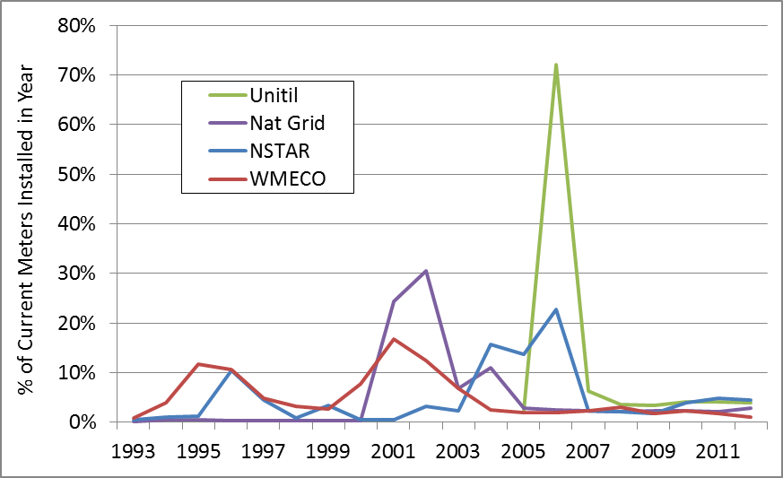
The Customer-Facing Subcommittee, with the help of the working group referenced previously developed a range of metering technology options beginning with AMR, which is currently the most common meter type in Massachusetts, and ending with AMI. Included in this range are several options to enhance basic AMR meters either through home area networks or fixed external area networks. Both of these are options are able to provide information back at the home office without having to gather the data during a drive by meter read. The Subcommittee and working group also learned about a new ITRON metering technology currently under development called a “Bridge AMI Meter” which can continue to act as an AMR meter, and then be switched remotely into AMI mode once a distribution company the utility has all other supporting AMI infrastructure in place. Finally the work group and Subcommittee looked at Unitil’s AMI system—which is a more limited AMI than full AMI, and looked at basic AMR with load control.
Table 4-C2: Metering Technology Options
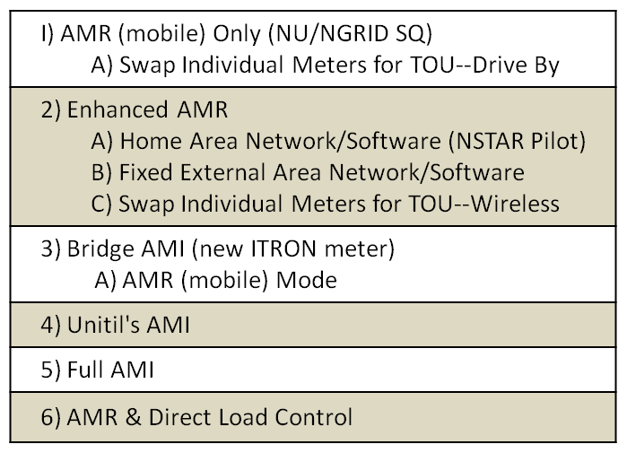

The working group then identified the potential meter-related functionalities of interest with 11 areas of focus shown in Table 4-C3. The working group and, ultimately the Subcommittee, then populated a matrix comparing each of the technologies in a different row with each of the 11 potential functions in a separate column to illustrate the technologies’ capabilities. The detailed matrix,labeled “Functionality” on the website, is located (HERE 4/23). A summary of the incremental customer-facing and grid-facing functionalities for key metering technology options is shown below in Table 4-C4: Incremental Functionality of Metering Options. Table 4-C4 illustrates that, as you progress from AMR through two types of enhanced AMR to AMI, additional functions in certain cases can and in other cases may be supported by the meters and associated infrastructure.
The Subcommittee and working group also worked to provide directional estimates of the costs related to the different metering technology options, including the costs of the meter and installation and a range of supporting infrastructure costs, as well as ongoing O&M costs. The cost ranges were developed with the assistance of Itron and with input from the Distribution Companies based on their experiences with their own infrastructure and pilot programs. (See Table 4-C5: Metering Technologies and Costs below).
The Subcommittee also, as a final exercise, reviewed the meter-related customer-facing and grid-facing functionalities and compared them to various clean energy related activities, such as demand response, distributed generation, direct load control, electric vehicles, etc.. Based on this review, it appears that there are two areas of meter-related functionalities with greatest relevance to clean energy activities: 1) communication to the meter and from the meter to customer devices; and 2) access to interval data on a real time basis. However, for some activities, such as electric vehicle recharging, if a TOU rate is sufficient, access to a TOU register, as opposed to interval data on a real time basis, might suffice to meet identified needs. (See Functionality & Applications worksheet of Metering Technologies Functions Costs spreadsheet HERE 4/23 and accompanying text Metering Functionality & Clean Energy Activity Text HERE 4/23)
It should be noted that, simply because a certain type of meter can support a particular capability or function, does not mean that it is necessarily the only way to enable those functions or that it is cost-effective. For instance, communication for enabling direct load control can be accomplished via other communications protocols without going through the meter.
The Subcommittee and Steering Committee did not endeavor to perform a cost-effectiveness analysis of the different metering technologies and their associated incremental functionality benefits. Rather, the Steering Committee anticipates that such an analysis would need to be performed on a company by company basis at the appropriate time.
Table 4-C3: Meter-Related Functionality

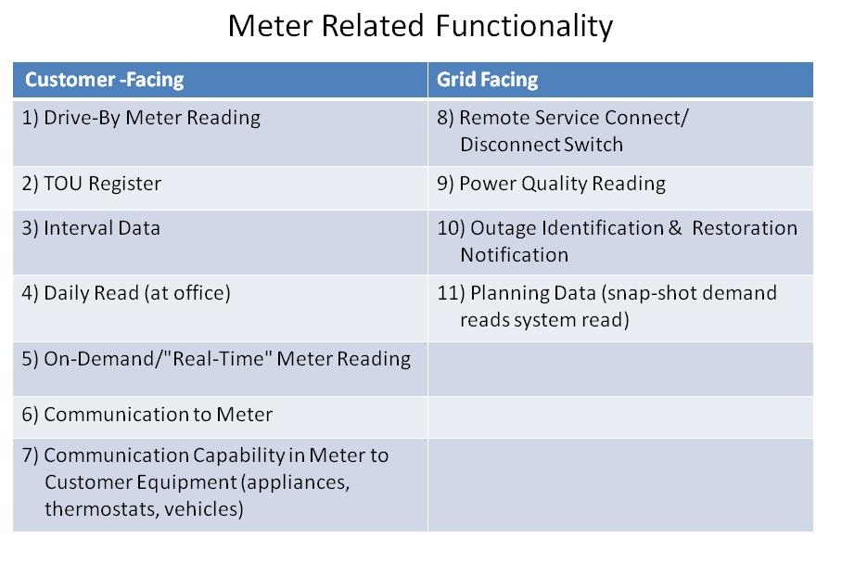

Table 4-C4: Incremental Functionality of Metering Options
Technology Options: | Customer-Facing | Grid-Facing
AMR | Drive-By Meter Reading; One-Way Communication
Enhanced AMR (w/HAN) | AMR PLUS Communication to Customer Equipment and MAY enable Remote Meter Read, TOU Register, Daily & Real-Time Meter Read | MAY enable Outage ID & Restoration Notification
Enhanced AMR (w/Fixed Network) | AMR PLUS Remote Meter Read, TOU Register, Interval Data, Daily Read, and MAY also enable Real Time Data Read, Communication to Customer Equipment | MAY/limited Outage ID & Restoration Notification, and Planning Data
Full AMI | AMR (w/Fixed Network) PLUS Real Time Data Read, Two-Way Communication to Meter, Communication to Customer Equipment, | AMR (w/Fixed Network) PLUS Remote Service Connect/Disconnect Switch, Voltage Reading, Power Quality Reading

Note: “MAY” is due to fact that some of functionality may not be available depending on which meter model is purchased and with some models certain functionality is optional and requires additional fees.
Table 4-C5: Meter Technologies and Costs
 | Meter (equipment) Costs | Installation Costs | Home Area Network Enablement | Software & Network Infrastructure | Other Smart Grid Infrastructure (OMS, DMS, GIS) | Total Cost (1) | DLC at Device (for interested customers) | Annual O&M (as percent of capital cost)
I) AMR Only (NU/NGRID SQ) | $30-50 | $20-40 | NA | $2 | NA | $52-92 | $100-150 | 10-30%
A) Swap Individual Meters for TOU--Drive By | $120 | $20-40 | NA | $2 | NA | $142-162 | $100-150 | 10-30%
2) Enhanced AMR
A) Home Area Network/Software | $30-50 | $100-200 | $125-175 | $2 | NA | $257-427 | $100-150 | 10-30%
B) Fixed Area Network/Software | $30-50 | $20-40 | NA | $15-30 | NA | $65-120 | $100-150 | 10-30%
C) Swap Individual Meters for TOU—Wireless | $300-600  (C&I only) | $20-40 | NA | $2 | NA | NA | $100-150 | 10-30%
3) Bridge AMI (new ITRON meter)
A) AMR (mobile) Mode | $120 | $20-40 | $125-175 | $ 2 | NA | $247-437 | $100-150 | 10-30%
B) AMI (network) Mode | $120 | $20-40 | $125-175 | $50-125 | $50-190 | $365-680 | $100-150 | 10-30%
4) AMI (Unitil SQ) | $70-150 | $20-40 | $75-150 | $50-125 | $50-190 | $265-655 | $100-150 | 10-30%
5) Full AMI (2) | $80-150 | $20-40 | $125-175 | $50-125 | $50-190 | $325-680 | $100-150 | 10-30%
6) AMR & Direct Load Control |  |  |  | $5-10 |  |  | $100-150 | 10-30%

Notes:
(1) The Total Costs are simply a total of the min-max individual costs. Actual upgrade costs will vary based on functionality deployed.
(2) Ranges on AMI in part related to different functionality
(3) Cost estimates based on combination of ITRON supplied cost, and MA utility experience
(4) In 3B if Bridge Meter already installed in "mobile" mode, no incremental equipment or labor cost to switch to AMI (network) mode
(5) Row 2A is based on NSTAR pilot costs, scale deployment could be different
(6) Software/Network Infrastructure cost relatively fixed, and likely lower cost/meter for large systems than small
(7) Other Smart Grid Infrastructure can vary significantly depending on pre-existing infrastructure and what other options to pursue
and based on ITRON's analysis of other jurisdictions
(8) For DLC end costs/installation same, but communications cost vary significantly--i.e., likely less expensive for AMI

Chapter 5: Principals/Recommendations

Distribution Company Recommendations on Principles (Chapter 5) for Grid Modernization Investments
Note: This chapter will include the recommendations of the Steering Committee on a wide range of grid modernization topics. Currently it includes the four sets of recommendations—A) Utilities (page 60); B) Clean Energy Caucus (page 64); C) AG (page 73); and D) Consolidated Version (page 80) of all 3 plus RESA principle on TVR. Please focus your review primarily on D) Consolidated Version as hopefully there can be further consolidation and this will likely be the version in the Final Report. Also, note that the recommendations on cost-effectiveness and the overall regulatory Framework can be found in other chapters. Finally see new principles from CEC on EVs and on owning DR.
Version A: Utilities
Chapter 5: Principles and Recommendations
The following includes the recommended principles and recommendations of the Steering Committee related to a wide range of grid modernization topics (including planning & investment; risk & reward; cost recovery; cyber-security; interoperability; metering; and time varying rates). [Note: This chapter is currently in DRAFT form—ultimately we will add the following language—“The principles and recommendations in this chapter represent a consensus of the Steering Committee unless otherwise noted. Where a consensus does not exist on a particular topic, two or more alternatives are presented with the supporting Steering Committee members noted.]

- Grid Modernization Responsibilities:

- Maintaining a reliable, safe, efficient and cost-effective distribution system is a core responsibility of the DPU and Massachusetts Distribution Companies.
  - The DPU establishes the policy and regulatory framework; identifies outcomes (possibly including specific targets and goals); oversees implementation, and enables sufficient cost recovery.
  - Distribution Companies develop and implement investment and operational plans to modernize the grid in a way that meets the outcomes within the policy and regulatory framework on balance with their obligation to provide reliable and safe service to customers.

- Planning & Investment:

- Distribution company investments in grid modernization capabilities, activities, and enablers should take into account the following:
  - Desired outcomes (see A.1.a.)
  - Existing technologies already in use on their network;
  - Geographic, demographic and system design characteristics of each Distribution Companies service territory;
  - Cost-effectiveness of alternative capabilities, activities, enablers, and alternatives to meet the desired outcome; and
  - Minimizing ratepayer impacts over the appropriate timeframes.

- When establishing the regulatory framework, the DPU should take into account the following considerations:
  - Distribution Company plans may need to account for long-term, multi-year efforts.
  - Plans should be flexible and allow for updates to accommodate evolving technology
  - The ultimate decision-making and responsibility for grid modernization investments remains with the Distribution Companies in keeping with their responsibility to provide reliable and safe service.
  - Stakeholder input should be provided in a timely, efficient manner to allow investments and operations for safe, reliable service to continue.
  - The Distribution Companies should consider the results from the ongoing Massachusetts smart grid pilots and other relevant pilot programs when evaluating potential grid modernization investments.
  - Grid modernization should be grounded in the DPU’s articulated principles regarding the development of service quality metrics and other performance metrics where appropriate.

- Risk & Reward/Cost Recovery:

- Capital investments in new and innovative capabilities, activities, and enablers are inherently more risky than investments in traditional assets due to their unproven track record and, as a result, the standard for cost recovery needs to reflect this additional risk.

- The prudent used and useful standard should be used for grid modernization investments. Notwithstanding the foregoing, reasonable investments that attempt to achieve grid modernization objectives should be eligible for recovery from customers.

- Cost Allocation:

- Grid modernization investments should be justified as beneficial to the customers that will pay for the costs of such investment through distribution service charges. Fair and equitable cost allocation and assignment principles should apply to determine cost responsibility for investments.

- Cyber-Security, Privacy and Interoperability:

- Cyber Security, Privacy and Interoperability are key considerations and must be elements of any grid modernization plan filed by the Distribution Companies.

- Interoperability

- Cyber Security, Privacy and Interoperability are key considerations and must be elements of any grid modernization plan filed by the Distribution Companies.

- Cost-Effectiveness:

See the accompanying Distribution Company Recommendation on Cost-Effectiveness Framework for Grid Modernization Investments.

- Metering:

- Metering Functionality
  - MA Distribution Companies’ path forward for metering should take into account:
    - The goals and desired functionality and outcomes
    - the starting point of each Distribution Company, e.g., their existing metering infrastructure, communications systems, billing systems, etc.; and
    - analysis of alternative investments/technologies and their relative costs and benefits.

- Customer Choice
- Any metering proposal must be considered within the context of state and federal policy and programs such as retail competition and energy efficiency and distributed resources.
- Individual electricity customer usage information should continue to be made available to the customer, or as directed by the customer, in a secure, convenient and timely manner to a 3rd party provider or vendor.
- Any metering proposal should address provisions for opting in vs opting out and any associated customer costs.

- Consumer Protections
  - Any advanced metering proposal should be implemented in a manner that ensures DPU approved consumer protections remain in place.

- Cost-effectiveness standards for metering investments should be consistent with the framework described above.

- Time Varying Rates (TVR):

Due to the complexities associated with TVR (e.g. what options to consider and who should provide those options, among others), we suggest that the Department open an investigation into the appropriate considerations for Time Varying Rates.

Version B: Clean Energy Caucus
Chapter 5: Principles and Recommendations
The following includes the recommended principles and recommendations of the Steering Committee related to a wide range of grid modernization topics (including planning & investment; risk & reward; cost recovery; cyber-security; interoperability; metering; and time varying rates). [Note: This chapter is currently in DRAFT form—ultimately we will add the following language—“The principles and recommendations in this chapter represent a consensus of the Steering Committee unless otherwise noted. Where a consensus does not exist on a particular topic, two or more alternatives are presented with the supporting Steering Committee members noted.]
- Grid Modernization Responsibilities:

- Grid modernization is a core responsibility of the DPU and Massachusetts electric distribution companies.
  - DPU’s role is to set up the policy and regulatory framework; specify outcomes (possibly including specific targets and goals); and oversee implementation.
  - Utilities’ role is to develop plans to meet the outcomes within the policy and regulatory framework, and to effectively implement their plans

- Grid Modernization Planning Process:

- Distribution company investments in grid modernization capabilities, activities, and enablers should be dictated by the following:
  - Specified outcomes, as ordered by the DPU;
  - Existing enabling technologies already in place on their network;
  - Geographic and demographic characteristics of each utilities’ service territory;
  - Cost-effectiveness of alternative capabilities, activities, enablers to meet the desired outcome; and
  - Maximizing customer benefits over the long term.

- DPU should issue an order that specifies outcomes of the modernized grid at the level of detail required to provide sufficient direction for utility plans and the appropriate regulatory policy framework

- Each utility should then file a company-specific grid modernization plan taking into account but not limited to the capabilities, activities, and enablers (shown in the Taxonomy chart in Chapter 3). The plan should indicate how the utility will integrate distributed resources and new technologies to capture the operational benefits they can provide to the distribution system.
- Utility grid modernization plans should (a) account for long-term, multi-year objectives and investments, and (b) right size equipment to take into account expected needs and desired outcomes over the planning horizon
  - Utilities should be provided with timely notification about plug-in electric vehicle purchases and charging equipment installations to facilitate strategic system-wide planning and ensure adequate and strategic distribution system upgrades.
- Each plan will indicate how the utility plans to integrate distributed resources and new technologies. Consistent with the goals of this report, the plan will specify incremental modernizing activities (beyond what is already happening through system planning) and describe how/whether they will further the integration of distributed resources. For instance, the plan should describe the ways in which it will lead to more DR integration related outcomes, such as, encouraging DR where it is valuable or useful; engaging in more transparent system planning with longer planning horizons and sharing of information about plans to modernize grid-facing equipment; reducing times and costs for interconnecting distributed generation; and participating actively in opportunities for professional learning, research and technical collaboration to inform and enable transformational increases in penetration and optimization of distributed resources.

- Utility grid modernization plans should be updated every 3-5 years (consistent with the regulatory framework) to reflect technology evolution and other new information

- There should be a process for stakeholder input into individual utility grid modernization plans, including but not limited to the identification of new technologies and other related investments and benefits

- Utilities should consider the results to date from the ongoing Massachusetts smart grid pilots and other relevant pilot programs when evaluating potential grid modernization investments, but should not wait to make grid-modernizing investments where benefits can be reasonably expected to exceed costs.
  - Some capabilities, activities, and enablers may benefit from additional pilot programs. Utilities should propose additional pilot programs where their analysis indicates that this would be the case.
  - Utilities should consider adjusting and fine tuning pilot program activities, including accelerating installation of technologies from pilot to standardized deployment where interim results indicate customer benefits.

- The grid modernization planning process should include consideration of interaction with existing related DPU processes and procedures, e.g., annual reliability reports; SQM; and DG Interconnection.

- Utilities should implement a multi-year grid modernization planning process that includes
  - Planning for non-wires alternatives, including geo-targeting of energy efficiency, demand response, distributed generation, storage
  - Planning for deployment of distributed generation, storage and microgrids
  - Planning for deployment of electric vehicles.

- Risk & Reward/Cost Recovery:

- Utility costs for investments in grid modernization should be recovered through the Utility of the Future Regulatory Framework described in [LOCATION].

- It should be recognized that capital investments in new and innovative capabilities, activities, and enablers may have different risks from investments in traditional assets. Although distribution companies currently bear the downside risk of disallowance if investments underperform, they should also have an opportunity to capture or share upside benefits when investments outperform expectations. The principle of risk symmetry is essential to promoting innovation and is recognized in the Utility of the Future Regulatory Framework.

- As with any other investment, the prudent, used, and useful standard should be used to evaluate the reasonableness of grid modernization investments.
- Cost Allocation:

- It should be recognized that utility investments in grid modernization that are prudent, used and useful will provide benefits to the system and customers as a whole and their costs should be recovered through distribution service charges. Cost allocation and assignment principles should apply to determine cost responsibility for investments.

- Cyber-Security and Privacy:

- Grid modernization raises new, complex, and potentially dangerous issues relating to security of the distribution grid, as well as the privacy of customer-specific information.

- The DPU should require the utilities to develop and seek approval of Cyber-Security plans, policies, and protocols as part of each grid modernization plan (as well as through any other regulatory procedures that the DPU may require). Utilities should have reporting requirements to demonstrate compliance with protocols. (Note: Portion of the plans may require confidential treatment to ensure system security.)

- Cyber-security, privacy, and inter-operability (including open access) are key considerations and key elements of any grid modernization plan filed by the distribution company and should be described and addressed in regulatory proceedings approving grid modernization plans and investments and throughout design and implementation of any new metering and other grid modernization technologies deployment.

- Interoperability:

- The utilities should be required to meet interoperability and open access standards that are consistent with industry standards (i.e., NIST) and subject to Department review and approval

- MA utilities should adopt the same standards where possible; and could potentially develop a common set of standards as follow-up to this proceeding.

- Interoperability and open access should be a key consideration in the evaluation of grid modernization technology and investment options to accommodate the evolution of nascent technologies, and to guard against near term obsolescence.

- Investment in meters, related customer-facing technologies, and grid-facing technologies should support a myriad of current and potential future customer- and grid-facing functions.

- Benefit-Cost Analysis (see separate Clean Energy Group benefit-cost analysis framework for additional detail):
  - Any utility filing for pre-approval of a grid modernization investment must include a full and public airing of the relevant benefits and costs.
  - For a grid modernization investment to be pre-approved the benefits should outweigh the cost.
  - The benefit-cost analysis framework for grid modernization investments should require the quantification of all applicable costs and benefits to the greatest extent possible.

- Cost-effectiveness analysis should include the whole range of costs and benefits, and should include both quantifiable and non-quantifiable factors

- Distribution company investments in capabilities, activities, and enablers must be cost-effective while maintaining a safe and stable transmission & distribution system. The determination of cost-effectiveness should be made on the basis of a more comprehensive set of potential benefits as described in the Benefit-Cost Analysis Framework referenced above, including, but not limited to:
- Reliability improvements as measured by Value of Lost Load (or some other agreed measure); and
- System benefits associated with integrating higher levels of distributed resources.

- Metering:
Metering Functionality
  - MA utilities path forward for metering should be dictated by:
    - The goals and desired functionality and outcomes [Note: See metering functionality matrix for depiction of the range of meter-related functionality and how it relates to different metering technologies and could help to enable various activities.]
    - the starting point of each utility (i.e., their existing metering infrastructure)
    - analysis of alternative investments/technologies and their relative costs and benefits
  - Metering for electric vehicles should be capable of realizing the benefits that result from the use of vehicle load to balance electricity demand and supply, smooth load curves, maintain operating frequency, and facilitate the integration of variable renewable resources.
- Customer Choice
- Any metering proposal and associated data-related infrastructure must give customers the power to choose – i.e., to make informed choices regarding energy product options (such as fixed and/or time-based prices for energy purchases, direct load control, demand response, energy generation, and energy storage including electric vehicles).
- Individual electricity customer usage information should be made available to the customer, or as directed by the customer, in a secure, convenient and timely manner to a 3rd party provider or vendor (e.g., through provision of uniform platforms and formats for access to customer data for customers and competitive suppliers).
- Opting Out of Advanced/Enhanced Meters:
    - Customers should be able to opt-out of metering choices and/or metering-related functionality; however, those customers should cover any additional costs associated with their opting out.
- Consumer Protections
  - Any metering investments/changes should be made consistent with the protection afforded by existing consumer protection regulations currently in place. To the extent that new technologies and investments may require additional or different regulations to protect customers, the Department should open a proceeding to develop such regulations.
  - Remote Disconnect/Connect (options)
- NECEC and the Clean Energy Group do not have a position on remote disconnections.
- Utilities should take advantage of remote connection capabilities afforded by grid modernization technologies.
- Third parties should be allowed access to meters and meter information consistent with customer information privacy rules to be developed.
- Integration with Communication Systems
- Consider existing telecommunications networks when considering communication options for the metering and distribution systems as part of the cost effectiveness and security and reliability analyses.
- Enhance utility critical information communication.

- Other Metering Principles
- Performance metrics should be established to measure the metering system’s reliability, accuracy, and security.
- Electric Vehicle Grid Modernization Principles

The Department should open a separate proceeding to consider the range of issues associated with the deployment of electric vehicles and their effect on the grid. The proceeding should address the following issues:

- Support a strategy that addresses an open market approach for a variety of business models relating to charging system ownership and payment operations. The strategy needs to encompass current and future technology and interconnection issues as well as private/public sector barriers.

- Incentivize off-peak charging of electric vehicles and avoid adverse grid impacts associated with vehicle charging.

- Develop a transparent customer billing process that is fair to all customers, helps develop the electric vehicle market and identifies best practices for charging them to avoid demand pricing.

- Encourage utilities to support short term and forward looking issues related to integrating electric vehicles into the grid to increase asset utilization and load management such as demand response as well as into the house or commercial property for emergency power.

- Encourage utilities to develop information sharing capacity to educate consumers and commercial entities about the benefits of EVs and develop partnerships with stakeholders to further advance outreach efforts. Utilities should develop communication plans to identify EV owners in their districts to control local impacts and enhance reliability of electricity services.

- Distributed Energy Resource Ownership Principles

- Consideration should be given to allowing utilities to own storage technologies and other distributed generation and distributed energy resources, where they would constitute distribution assets, to optimize the use of the distribution system.

- Consideration should be given to allowing utilities to contract with 3rd parties for the use of storage and distributed energy resources, to optimize the use of the distribution system.

- Utilities must demonstrate that the benefits of ownership or contracts for storage and/or distributed energy resources can be reasonably expect to exceed the costs over the life of the assets.

- Time Varying Rates (TVR):

- Foundational
  - Rates should be cost based
  - Prudent, used, and useful costs associated with analysis and implementation of time varying rates should be recoverable
  - TVR should be done in competitively neutral manner—not undermining competitive retail markets
  - Due to the complexities associated with TVR (e.g., what options to consider and who should provide those options, among others), the Department open an investigation into the appropriate considerations for Time Varying Rates.

- Coverage

- Customer Classes
- TVR options should be available in all customer rate classes—although types of TVR may vary among rate classes
- TVR should be available to electric vehicles, and utility tariffs should be designed to encourage charging during off-peak hours to minimize adverse impacts on the system.
      - Utilities should provide transparent information on the price of electricity as a transportation fuel and educate electric vehicle consumers on the benefits and impacts of using off-peak charging.
- Distribution rates vs. supply/energy-side vs. both?
- When designing a time-varying rate option to achieve applicable peak load reduction, demand response and/or other objectives, distribution utilities should analyze the benefits and costs and effectiveness of time varying rates for both distribution and supply rates.

- Type of Time Varying Rates
- Evaluate the benefits and costs of a range of TVR options—seeking the appropriate option(s) for each customer class.

- Opt In vs. Opt Out vs. Mandatory Time Varying Rates
- The default retail pricing option should be determined based on the same cost-effectiveness analysis framework as that used to determine metering and other grid modernizing technology cost-effectiveness. The analysis should consider the benefits and costs of alternative TVR designs and whether customers should opt-into, or opt-out of, the default TVR option.

- Evaluating Options
- Analysis of pilots, existing TOU rates, and market research completed to date should be included in each utility’s grid modernization plan to evaluate customer interests, concerns, and understanding.
- The decision to pursue time varying rates needs to be evaluated in terms of the life-cycle costs and benefits produced over time, and should include costs associated with engaging and educating customers
- Any analysis of costs associated to offer time-varying rates by distribution utilities should evaluate potential bill impacts for each option offered compared to the standard or default rate.
- In order to enable time varying rates, all technology options should be explored and the focus should be on technologies that provide utilities greater flexibility at a lower cost.

- Interface Between TVR and Markets
  - TVR enabled by 2-way communication should support the Commonwealth’s commitment to competitive wholesale & retail markets.
  - Grid modernization should improve connection between wholesale and retail markets

- Customer Education Around TVR
- Commit resources within rates to educate and engage customers on TVR
- Educate and engage customers for purpose of controlling energy use and support state’s clean energy goals
- New rate structures and information from advanced metering should foster customer education, behavioral changes and participation in energy efficiency and demand response programs.

- Other TVR Related Principles/Recommendations
  - Time Varying Rates should be designed to facilitate the adoption by customers of a broad range of distributed energy resources and demand response technologies to enable them to capture the benefits these resources and technologies offer.
  - Distribution utilities should offer a default service rate that encourages customer participation in the competitive market while providing stable default service for residential and small commercial customers who may have limited options.
Version C: Attorney General
Chapter 5: Principles and Recommendations
The following includes the recommended principles and recommendations of the Steering Committee related to a wide range of grid modernization topics (including planning & investment; risk & reward; cost recovery; cyber-security; interoperability; metering; and time varying rates). [Note: This chapter is currently in DRAFT form—ultimately we will add the following language—“The principles and recommendations in this chapter represent a consensus of the Steering Committee unless otherwise noted. Where a consensus does not exist on a particular topic, two or more alternatives are presented with the supporting Steering Committee members noted.]
- Grid Modernization Responsibilities:
As part of their ongoing obligation to provide reliable and safe service to all customers, and especially sensitive populations such as low-income customers, utilities should evaluate and invest in grid modernization technologies if: (a) the benefits exceed the costs of the investment (b) the investments are prudent, and used and useful (c) investment is demonstrated to be least cost as compared to other alternative investments, and (d) the investment will result in affordable rates and bills for customers. Specifically, subject to these constraints, utilities should plan for and adopt such grid modernization technologies that have been demonstrated to achieve the following results:

- reduce distribution and generation supply costs;
- enhance the reliability of electricity service;
- improve the operational efficiency of the grid;
- enhance the ability of the grid to support the integration of distributed generation, demand response, storage technologies;
- enable customers to better manage their use of electricity;
- help achieve the state’s environmental and clean energy goals;
- continue to support and sustain the competitive energy markets in New England and the provision of competitive electricity services in the Commonwealth, and;
- maintain the stability of the grid.

The Department should consider bill impacts, particularly for low-income customers, in its consideration of grid modernization investments, both in terms of individual investment proposals and the combined impact of these and other statutorily mandated investments in efficiency and renewable resources. Such a consideration may drive the need for identification of phased implementation and priorities in grid modernization.

- Planning & Investment:
- The utilities investments in grid modernization capabilities, activities, and enablers should be guided by the following:
  - The Grid Modernization responsibilities set forth above in Principle No. 1
  - Desired outcomes set forth in Chapter 3 of this report;
  - Existing enabling technologies already in place on their network;
  - Characteristics of the utility’s customer base;
  - Geographic and demographic characteristics of each utilities’ service territory;
  - The reasonable and prudent and used and useful standards;
  - Analysis of costs and benefits of reasonable options to achieve the desired results, and;
  - Affordability and minimization of ratepayer bill impacts.
- Utility plans would need to account for short-term, long-term, multi-year investment plans, and specific investment projects and proposals. The plans should include, where applicable, preliminary cost estimates, impacts on customer reliability, grid operations, usage reduction, peak load reduction, impact on energy prices, and bill impacts on customers by rate class.
- Stakeholders should continue to provide input into utilities grid modernization planning in the various Department proceedings as appropriate. As appropriate, developers, technology companies, individual customers and others with individual needs may seek to facilitate individual needs or desires through participation in Department proceeding, or direct contact with utility staff.
- Utilities should consider the results from the ongoing Massachusetts smart grid pilots and other relevant pilot programs when evaluating potential grid modernization investments. The utilities may find that customers could potentially benefit from testing certain grid modernization technologies, capabilities, activities, and enablers through additional pilot programs. If the utilities do conduct additional pilot programs, all program results should be made publicly available. However, customers should not fund research and development through pilot programs.
- Any new grid modernization process should consider how it interacts with existing related DPU processes and procedures, e.g., annual reliability reports; SQM; and DG Interconnection. A resolution for potential conflicts with existing Department processes and procedures must be identified prior to adoption of any grid modernization policy, plan or process.

- Risk & Reward/Cost Recovery:

- Capital investments in some grid modernization technologies, those that are new and innovative, are inherently more risky than investments in traditional assets. The level of such risk should be taken into account when determining the scope, scale, and potential bill impacts associated with such proposals. Customers should not bear the risk for new and innovative technologies.
- As with any other investment, utilities must be held accountable for estimated costs and benefits of grid facing investments, and impacts on customer’s bill and rates.
- Cost Allocation:

- Grid modernization investments should be justified as beneficial to the customers that will pay for the costs of such investment through distribution service charges, and cost allocation and assignment principles should apply to determine cost responsibility for investments. Costs should be allocated exclusively to beneficiaries of those costs.

- Cyber-Security and Privacy:

- Deployment of grid modernization technologies raises new, complex, and potentially dangerous issues relating to the security of the electric distribution grid and customer-specific information. The Department should require the utilities to demonstrate the adequacy of their cyber-security plans, policies and protocols on an ongoing, annual basis. If a utility makes a request for approval of a new advanced metering and/or wireless communication system, the Department should require the utilities to demonstrate that the cyber security plans, policies and protocols adequately address security concerns prior to or during the proceeding in which the Department reviews the request.
- Interoperability:

- The utilities should be required to meet interoperability standards that are consistent with industry standards and subject to Department review and approval. Such standards shall not be used to require or otherwise justify investments into new, risky and emerging technologies, investments that would undermine the affordability of customer’s rates and bills, or that are not demonstrated to be cost effective, and prudent and used and useful.

- Cost-Effectiveness:

- Grid facing investments that utilities choose to make must be demonstrated to have proven benefits and must be least cost, prudent, used and useful and benefits must exceed the costs. Like any other investment, utilities must be held accountable for estimated costs and benefits of grid facing investments. [NOTE: AGO has dealt with this issue more fully in the separate homework assignment. It is unclear as to whether the principles for cost-effectiveness should be included here, or in Chapter 6.]

- Metering:

- Metering Functionality
If a utility desires to install advanced metering capabilities in order to achieve certain goals and desired functionalities and outcomes, the utility should be required to demonstrate a net benefit of a full system wide advanced meter rollout. Otherwise, the utility should be required to provide technology to collect time of use data for those who request them, including electric vehicles and target resources on a beneficiary pays basis.
- Customer Choice
- Individual electricity customer usage information should be made available to the customer, or as directed by the customer, in a secure, convenient and timely manner to a 3rd party provider or vendor pursuant to 220 CMR § 11.04(12)(b) and other existing applicable laws and regulations.
- Opting Out of Advanced/Enhanced Meters:
  - For a full meter rollout, customers should be able to opt-out of metering choices and/or metering-related functionality.

- Consumer Protections
  - Any metering investments/changes should be made consistent with pre-existing consumer protections which should remain in place.
  - Advanced meter investments (either AMI or enhanced AMR) should not result in reduced levels of consumer protections, especially relating to the implementation of billing, collection, payment plans, and dispute rights reflected in current DPU and utility policies and programs.
  - Before entertaining any grid modernization filings or proposals, customer privacy policies and regulations must be reassessed and further developed to address the customer specific data that is enabled with some grid modernization technologies. Such policies should reflect and affirm that affirmative customer authorization is required prior to allowing utilities to enable access to such data to any third party, including utility affiliates and otherwise comply with the General Laws and regulations promulgated thereunder. See, e.g., 220 CMR § 11.05(4).
  - Remote Disconnect/Connect
- Shut-offs for nonpayment should not occur remotely.
- The remote disconnection and connection chip or functionality of smart meters should not be installed for cost, consumer protection and cyber-security reasons.
- Utilities should continue to develop targeted collections programs and policies, many of which may reduce the incidence of disconnection for nonpayment, but any such initiatives should conform to existing consumer protection policies and programs.
- No third party should be allowed to access the utility’s meter to remotely disconnect or reconnect the meter. Any third party or energy supplier should be required to implement metering actions through the distribution utility and demonstrate compliance with the same consumer protections as required by the distribution utility.
- Cost-Effectiveness of Meter Investments (and related communications & data management infrastructure)
  - Any proposal to replace the current metering system and install Advanced Metering Infrastructure (metering, communication systems, and meter data management systems) must demonstrate that the customer benefits will exceed the incremental costs. This principle is particularly important due to the metering systems installed by Massachusetts distribution utilities that already reflect a high level of operational efficiency. Stranded costs should be included in this analysis.
    - Investments in advanced metering systems should be justified as beneficial to the customers that will pay for the costs of such investment through distribution service or base rates and through default service (generation supply price). Benefits that may accrue to third party vendors or that enable services that may be offered by third parties should not drive such investment decisions unless the third parties are required to assist in payment for these incremental costs.
    - In making an advanced metering proposal, utilities should consider and evaluate all options that may result in more effective use of the current metering system or more modest investments that would achieve agreed upon objectives at the least cost, such as direct load control.
  - Critically evaluate goals & aspirations for TVR and C-F techs in context of facts as foundation for policy—don’t make policy on theoretical benefits, opportunities, & goals. At a minimum, the ongoing Massachusetts smart grid pilots should be evaluated and completed prior to making assumptions about the costs and benefits of significant additional costs for advanced metering and communication systems. [Other Subcommittee members concerned about the “prior to” language.]
- Other Metering Principles
  - Performance metrics should be established to measure the metering system’s reliability, accuracy, and security.
- Time Varying Rates (TVR):
- Coverage
  - Customer Classes
    - The Department should not require utilities to provide TVR to all customer rate classes.
  - Distribution rates vs. supply/energy-side vs. both?
    - When designing a time-varying rate option or direct load control program to achieve applicable peak load reduction or demand response objectives, distribution utilities should focus primarily on the supply side of the electricity bill.
- Type of Time Varying Rates
  - When considering options for TVR for distribution utilities, the DPU should give priority to peak time rebate programs.

- Opt In vs. Opt Out vs. Mandatory Time Varying Rates
  - Time Varying Rates must not be mandatory for residential or low-income customers; consumers should be allowed to opt-in to TVR options.

- Evaluating Options
  - Options that include rebates should clearly identify the source to pay those rebates and the proposal should show that customer benefits exceed the customer costs.

- Interface Between TVR and Markets
  - TVR enabled by 2-way communication should support the Commonwealth’s commitment to competitive wholesale & retail markets.

Version D: Consolidated Version
Chapter 5: Principles and Recommendations
The following includes the recommended principles and recommendations of the Steering Committee related to a wide range of grid modernization topics (including planning & investment; risk & reward; cost recovery; cyber-security; interoperability; metering; and time varying rates). [Note: This chapter is currently in DRAFT form—ultimately we will add the following language—“The principles and recommendations in this chapter represent a consensus of the Steering Committee unless otherwise noted. Where a consensus does not exist on a particular topic, two or more alternatives are presented with the supporting Steering Committee members noted.]
- Grid Modernization Responsibilities:

- [Utilities] Maintaining a reliable, safe, efficient and cost-effective distribution system is a core responsibility of the DPU and Massachusetts Distribution Companies.
  - The DPU establishes the policy and regulatory framework; identifies outcomes (possibly including specific targets and goals); oversees implementation, and enables sufficient cost recovery.
  - Distribution Companies develop and implement investment and operational plans to modernize the grid in a way that meets the outcomes within the policy and regulatory framework on balance with their obligation to provide reliable and safe service to customers.
- [CEC] Grid modernization is a core responsibility of the DPU and Massachusetts electric distribution companies.
  - DPU’s role is to set up the policy and regulatory framework; specify outcomes (possibly including specific targets and goals); and oversee implementation.
  - Utilities’ role is to develop plans to meet the outcomes within the policy and regulatory framework, and to effectively implement their plans
- [AG] As part of their ongoing obligation to provide reliable and safe service to all customers, and especially sensitive populations such as low-income customers, utilities should evaluate and invest in grid modernization technologies if:
  - the benefits exceed the costs of the investment
  - the investments are prudent, and used and useful
  - investment is demonstrated to be least cost as compared to other alternative investments
  - the investment will result in affordable rates and bills for customers. Specifically, subject to these constraints, utilities should plan for and adopt such grid modernization technologies that have been demonstrated to achieve the following results:
    - reduce distribution and generation supply costs;
    - enhance the reliability of electricity service;
    - improve the operational efficiency of the grid;
    - enhance the ability of the grid to support the integration of distributed generation, demand response, storage technologies;
    - enable customers to better manage their use of electricity;
    - help achieve the state’s environmental and clean energy goals;
    - continue to support and sustain the competitive energy markets in New England and the provision of competitive electricity services in the Commonwealth, and;
    - maintain the stability of the grid.

The Department should consider bill impacts, particularly for low-income customers, in its consideration of grid modernization investments, both in terms of individual investment proposals and the combined impact of these and other statutorily mandated investments in efficiency and renewable resources. Such a consideration may drive the need for identification of phased implementation and priorities in grid modernization.
- Planning & Investment:

1A.[Utilities] Distribution company investments in grid modernization capabilities, activities, and enablers should take into account the following:
  - Desired outcomes (see A.1.a.)
  - Existing technologies already in use on their network;
  - Geographic, demographic and system design characteristics of each Distribution Companies service territory;
  - Cost-effectiveness of alternative capabilities, activities, enablers, and alternatives to meet the desired outcome; and
  - Minimizing ratepayer impacts over the appropriate timeframes.

1B. [CEC] Distribution company investments in grid modernization capabilities, activities, and enablers should be dictated by the following:
  - Specified outcomes, as ordered by the DPU;
  - Existing enabling technologies already in place on their network;
  - Geographic and demographic characteristics of each utilities’ service territory;
  - Cost-effectiveness of alternative capabilities, activities, enablers to meet the desired outcome; and
  - Maximizing customer benefits over the long term.

1C. [AG] The utilities investments in grid modernization capabilities, activities, and enablers should be guided by the following:
  - The Grid Modernization responsibilities set forth above in Principle No. 1
  - Desired outcomes set forth in Chapter 3 of this report;
  - Existing enabling technologies already in place on their network;
  - Characteristics of the utility’s customer base;
  - Geographic and demographic characteristics of each utilities’ service territory;
  - The reasonable and prudent and used and useful standards;
  - Analysis of costs and benefits of reasonable options to achieve the desired results, and;
  - Affordability and minimization of ratepayer bill impacts.
- [Utilities] When establishing the regulatory framework, the DPU should take into account the following considerations:
  - Distribution Company plans may need to account for long-term, multi-year efforts.
  - Plans should be flexible and allow for updates to accommodate evolving technology
  - The ultimate decision-making and responsibility for grid modernization investments remains with the Distribution Companies in keeping with their responsibility to provide reliable and safe service.
  - Stakeholder input should be provided in a timely, efficient manner to allow investments and operations for safe, reliable service to continue.
  - The Distribution Companies should consider the results from the ongoing Massachusetts smart grid pilots and other relevant pilot programs when evaluating potential grid modernization investments.
  - Grid modernization should be grounded in the DPU’s articulated principles regarding the development of service quality metrics and other performance metrics where appropriate.

- [CEC] DPU should issue an order that specifies outcomes of the modernized grid at the level of detail required to provide sufficient direction for utility plans and the appropriate regulatory policy framework

- [CEC] Each utility should then file a company-specific grid modernization plan taking into account but not limited to the capabilities, activities, and enablers (shown in the Taxonomy chart in Chapter 3). The plan should indicate how the utility will integrate distributed resources and new technologies to capture the operational benefits they can provide to the distribution system.

- [CEC] Utility grid modernization plans should (a) account for long-term, multi-year objectives and investments, and (b) right size equipment to take into account expected needs and desired outcomes over the planning horizon
- Utilities should be provided with timely notification about plug-in electric vehicle purchases and charging equipment installations to facilitate strategic system-wide planning and ensure adequate and strategic distribution system upgrades.
- Each plan will indicate how the utility plans to integrate distributed resources and new technologies. Consistent with the goals of this report, the plan will specify incremental modernizing activities (beyond what is already happening through system planning) and describe how/whether they will further the integration of distributed resources. For instance, the plan should describe the ways in which it will lead to more DR integration related outcomes, such as, encouraging DR where it is valuable or useful; engaging in more transparent system planning with longer planning horizons and sharing of information about plans to modernize grid-facing equipment; reducing times and costs for interconnecting distributed generation; and participating actively in opportunities for professional learning, research and technical collaboration to inform and enable transformational increases in penetration and optimization of distributed resources.

- [CEC] Utility grid modernization plans should be updated every 3-5 years (consistent with the regulatory framework) to reflect technology evolution and other new information

- [CEC] There should be a process for stakeholder input into individual utility grid modernization plans, including but not limited to the identification of new technologies and other related investments and benefits

- [CEC] Utilities should consider the results to date from the ongoing Massachusetts smart grid pilots and other relevant pilot programs when evaluating potential grid modernization investments, but should not wait to make grid-modernizing investments where benefits can be reasonably expected to exceed costs.
- Some capabilities, activities, and enablers may benefit from additional pilot programs. Utilities should propose additional pilot programs where their analysis indicates that this would be the case.
- Utilities should consider adjusting and fine tuning pilot program activities, including accelerating installation of technologies from pilot to standardized deployment where interim results indicate customer benefits.

- [CEC] The grid modernization planning process should include consideration of interaction with existing related DPU processes and procedures, e.g., annual reliability reports; SQM; and DG Interconnection.

- [CEC] Utilities should implement a multi-year grid modernization planning process that includes
  - Planning for non-wires alternatives, including geo-targeting of energy efficiency, demand response, distributed generation, storage
  - Planning for deployment of distributed generation, storage and microgrids
  - Planning for deployment of electric vehicles.

- [AG] Utility plans would need to account for short-term, long-term, multi-year investment plans, and specific investment projects and proposals. The plans should include, where applicable, preliminary cost estimates, impacts on customer reliability, grid operations, usage reduction, peak load reduction, impact on energy prices, and bill impacts on customers by rate class.

- [AG] Stakeholders should continue to provide input into utilities grid modernization planning in the various Department proceedings as appropriate. As appropriate, developers, technology companies, individual customers and others with individual needs may seek to facilitate individual needs or desires through participation in Department proceeding, or direct contact with utility staff.

- [AG] Utilities should consider the results from the ongoing Massachusetts smart grid pilots and other relevant pilot programs when evaluating potential grid modernization investments. The utilities may find that customers could potentially benefit from testing certain grid modernization technologies, capabilities, activities, and enablers through additional pilot programs. If the utilities do conduct additional pilot programs, all program results should be made publicly available. However, customers should not fund research and development through pilot programs.

- [AG] Any new grid modernization process should consider how it interacts with existing related DPU processes and procedures, e.g., annual reliability reports; SQM; and DG Interconnection. A resolution for potential conflicts with existing Department processes and procedures must be identified prior to adoption of any grid modernization policy, plan or process.
- Risk & Reward/Cost Recovery:

1A.[Utilities] Capital investments in new and innovative capabilities, activities, and enablers are inherently more risky than investments in traditional assets due to their unproven track record and, as a result, the standard for cost recovery needs to reflect this additional risk.

1B. [CEC] It should be recognized that capital investments in new and innovative capabilities, activities, and enablers may have different risks from investments in traditional assets. Although distribution companies currently bear the downside risk of disallowance if investments underperform, they should also have an opportunity to capture or share upside benefits when investments outperform expectations. The principle of risk symmetry is essential to promoting innovation and is recognized in the Utility of the Future Regulatory Framework

1C. [AG] Capital investments in some grid modernization technologies, those that are new and innovative, are inherently more risky than investments in traditional assets. The level of such risk should be taken into account when determining the scope, scale, and potential bill impacts associated with such proposals. Customers should not bear the risk for new and innovative technologies.

2A. [Utilities] The prudent used and useful standard should be used for grid modernization investments. Notwithstanding the foregoing, reasonable investments that attempt to achieve grid modernization objectives should be eligible for recovery from customers

2B. [CEC] As with any other investment, the prudent, used, and useful standard should be used to evaluate the reasonableness of grid modernization investments

3.[CEC] Utility costs for investments in grid modernization should be recovered through the Utility of the Future Regulatory Framework described in [LOCATION].

- [AG] As with any other investment, utilities must be held accountable for estimated costs and benefits of grid facing investments, and impacts on customer’s bill and rates.
- Cost Allocation:

1A.[Utilities] Grid modernization investments should be justified as beneficial to the customers that will pay for the costs of such investment through distribution service charges. Fair and equitable cost allocation and assignment principles should apply to determine cost responsibility for investments.
1B.[AG] Grid modernization investments should be justified as beneficial to the customers that will pay for the costs of such investment through distribution service charges, and cost allocation and assignment principles should apply to determine cost responsibility for investments. Costs should be allocated exclusively to beneficiaries of those
1C. [CEC] It should be recognized that utility investments in grid modernization that are prudent, used and useful will provide benefits to the system and customers as a whole and their costs should be recovered through distribution service charges. Cost allocation and assignment principles should apply to determine cost responsibility for investments.

- Cyber-Security, Privacy and Interoperability:

- [Utilities] Cyber Security, Privacy and Interoperability are key considerations and must be elements of any grid modernization plan filed by the Distribution Companies.

- [AG] Deployment of grid modernization technologies raises new, complex, and potentially dangerous issues relating to the security of the electric distribution grid and customer-specific information. The Department should require the utilities to demonstrate the adequacy of their cyber-security plans, policies and protocols on an ongoing, annual basis. If a utility makes a request for approval of a new advanced metering and/or wireless communication system, the Department should require the utilities to demonstrate that the cyber security plans, policies and protocols adequately address security concerns prior to or during the proceeding in which the Department reviews the request.
- [CEC] Grid modernization raises new, complex, and potentially dangerous issues relating to security of the distribution grid, as well as the privacy of customer-specific information.

- [CEC] The DPU should require the utilities to develop and seek approval of Cyber-Security plans, policies, and protocols as part of each grid modernization plan (as well as through any other regulatory procedures that the DPU may require). Utilities should have reporting requirements to demonstrate compliance with protocols. (Note: Portion of the plans may require confidential treatment to ensure system security.)

- [CEC] Cyber-security, privacy, and inter-operability (including open access) are key considerations and key elements of any grid modernization plan filed by the distribution company and should be described and addressed in regulatory proceedings approving grid modernization plans and investments and throughout design and implementation of any new metering and other grid modernization technologies deployment.

- Interoperability

- [Utilities] Cyber Security, Privacy and Interoperability are key considerations and must be elements of any grid modernization plan filed by the Distribution Companies.

- [AG] The utilities should be required to meet interoperability standards that are consistent with industry standards and subject to Department review and approval. Such standards shall not be used to require or otherwise justify investments into new, risky and emerging technologies, investments that would undermine the affordability of customer’s rates and bills, or that are not demonstrated to be cost effective, and prudent and used and useful.
- [CEC] The utilities should be required to meet interoperability and open access standards that are consistent with industry standards (i.e., NIST) and subject to Department review and approval

- [CEC] MA utilities should adopt the same standards where possible; and could potentially develop a common set of standards as follow-up to this proceeding.
- [CEC] Interoperability and open access should be a key consideration in the evaluation of grid modernization technology and investment options to accommodate the evolution of nascent technologies, and to guard against near term obsolescence.
- [CEC] Investment in meters, related customer-facing technologies, and grid-facing technologies should support a myriad of current and potential future customer- and grid-facing functions.

- Cost-Effectiveness:

See separate chapter on detailed cost-effectiveness recommendations

- Metering:

Metering Functionality
1A, [Utilities] MA Distribution Companies’ path forward for metering should take into account:
  - The goals and desired functionality and outcomes
  - the starting point of each Distribution Company, e.g., their existing metering infrastructure, communications systems, billing systems, etc.; and
    - analysis of alternative investments/technologies and their relative costs and benefits.

1B. [CEC] MA utilities path forward for metering should be dictated by:
- The goals and desired functionality and outcomes [Note: See metering functionality matrix for depiction of the range of meter-related functionality and how it relates to different metering technologies and could help to enable various activities.]
- the starting point of each utility (i.e., their existing metering infrastructure)
- analysis of alternative investments/technologies and their relative costs and benefits
- Metering for electric vehicles should be capable of realizing the benefits that result from the use of vehicle load to balance electricity demand and supply, smooth load curves, maintain operating frequency, and facilitate the integration of variable renewable resources.

1C. [AG] If a utility desires to install advanced metering capabilities in order to achieve certain goals and desired functionalities and outcomes, the utility should be required to demonstrate a net benefit of a full system wide advanced meter rollout. Otherwise, the utility should be required to provide technology to collect time of use data for those who request them, including electric vehicles and target resources on a beneficiary pays basis.
1. [Utilities} Customer Choice
- Any metering proposal must be considered within the context of state and federal policy and programs such as retail competition and energy efficiency and distributed resources.
- Individual electricity customer usage information should continue to be made available to the customer, or as directed by the customer, in a secure, convenient and timely manner to a 3rd party provider or vendor.
- Any metering proposal should address provisions for opting in vs opting out and any associated customer costs.

- [CEC] Customer Choice
- Any metering proposal and associated data-related infrastructure must give customers the power to choose – i.e., to make informed choices regarding energy product options (such as fixed and/or time-based prices for energy purchases, direct load control, demand response, energy generation, and energy storage including electric vehicles).
- Individual electricity customer usage information should be made available to the customer, or as directed by the customer, in a secure, convenient and timely manner to a 3rd party provider or vendor (e.g., through provision of uniform platforms and formats for access to customer data for customers and competitive suppliers).
- Opting Out of Advanced/Enhanced Meters:
- Customers should be able to opt-out of metering choices and/or metering-related functionality; however, those customers should cover any additional costs associated with their opting out.

- [AG] Customer Choice
- Individual electricity customer usage information should be made available to the customer, or as directed by the customer, in a secure, convenient and timely manner to a 3rd party provider or vendor pursuant to 220 CMR § 11.04(12)(b) and other existing applicable laws and regulations.
- Opting Out of Advanced/Enhanced Meters:
- For a full meter rollout, customers should be able to opt-out of metering choices and/or metering-related functionality

- [Utilities] Consumer Protections
  - Any advanced metering proposal should be implemented in a manner that ensures DPU approved consumer protections remain in place.

- [CEC] Consumer Protections
  - Any metering investments/changes should be made consistent with the protection afforded by existing consumer protection regulations currently in place. To the extent that new technologies and investments may require additional or different regulations to protect customers, the Department should open a proceeding to develop such regulations.
  - Remote Disconnect/Connect (options)
- NECEC and the Clean Energy Group do not have a position on remote disconnections.
- Utilities should take advantage of remote connection capabilities afforded by grid modernization technologies.
- Third parties should be allowed access to meters and meter information consistent with customer information privacy rules to be developed.

- [AG] Consumer Protections
- Any metering investments/changes should be made consistent with pre-existing consumer protections which should remain in place.
- Advanced meter investments (either AMI or enhanced AMR) should not result in reduced levels of consumer protections, especially relating to the implementation of billing, collection, payment plans, and dispute rights reflected in current DPU and utility policies and programs.
- Before entertaining any grid modernization filings or proposals, customer privacy policies and regulations must be reassessed and further developed to address the customer specific data that is enabled with some grid modernization technologies. Such policies should reflect and affirm that affirmative customer authorization is required prior to allowing utilities to enable access to such data to any third party, including utility affiliates and otherwise comply with the General Laws and regulations promulgated thereunder. See, e.g., 220 CMR § 11.05(4).
- Remote Disconnect/Connect
- Shut-offs for nonpayment should not occur remotely.
- The remote disconnection and connection chip or functionality of smart meters should not be installed for cost, consumer protection and cyber-security reasons.
- Utilities should continue to develop targeted collections programs and policies, many of which may reduce the incidence of disconnection for nonpayment, but any such initiatives should conform to existing consumer protection policies and programs.
- No third party should be allowed to access the utility’s meter to remotely disconnect or reconnect the meter. Any third party or energy supplier should be required to implement metering actions through the distribution utility and demonstrate compliance with the same consumer protections as required by the distribution utility.

- [CEC/AG] Other Metering Principles
- Performance metrics should be established to measure the metering system’s reliability, accuracy, and security

- [CEC] Integration with Communication Systems
  - Consider existing telecommunications networks when considering communication options for the metering and distribution systems as part of the cost effectiveness and security and reliability analyses.
  - Enhance utility critical information communication.

- Time Varying Rates (TVR):

- [Utilities/CEC] Due to the complexities associated with TVR (e.g. what options to consider and who should provide those options, among others), we suggest that the Department open an investigation into the appropriate considerations for Time Varying Rates.

- [CEC] Time Varying Rates (TVR):Foundational
  - Rates should be cost based
  - Prudent, used, and useful costs associated with analysis and implementation of time varying rates should be recoverable
  - TVR should be done in competitively neutral manner—not undermining competitive retail markets
- [CEC] Coverage
  - Customer Classes
    - TVR options should be available in all customer rate classes—although types of TVR may vary among rate classes
    - TVR should be available to electric vehicles, and utility tariffs should be designed to encourage charging during off-peak hours to minimize adverse impacts on the system.
      - Utilities should provide transparent information on the price of electricity as a transportation fuel and educate electric vehicle consumers on the benefits and impacts of using off-peak charging.
  - Distribution rates vs. supply/energy-side vs. both?
    - When designing a time-varying rate option to achieve applicable peak load reduction, demand response and/or other objectives, distribution utilities should analyze the benefits and costs and effectiveness of time varying rates for both distribution and supply rates.

- [AG] Coverage
- Customer Classes
- The Department should not require utilities to provide TVR to all customer rate classes.
- Distribution rates vs. supply/energy-side vs. both?
- When designing a time-varying rate option or direct load control program to achieve applicable peak load reduction or demand response objectives, distribution utilities should focus primarily on the supply side of the electricity bill.
- [CEC] Type of Time Varying Rates
  - Evaluate the benefits and costs of a range of TVR options—seeking the appropriate option(s) for each customer class.

- [ AG] Type of Time Varying Rates
- When considering options for TVR for distribution utilities, the DPU should give priority to peak time rebate programs.

- [CEC] Opt In vs. Opt Out vs. Mandatory Time Varying Rates
  - The default retail pricing option should be determined based on the same cost-effectiveness analysis framework as that used to determine metering and other grid modernizing technology cost-effectiveness. The analysis should consider the benefits and costs of alternative TVR designs and whether customers should opt-into, or opt-out of, the default TVR option.

- [AG] Opt In vs. Opt Out vs. Mandatory Time Varying Rates
- Time Varying Rates must not be mandatory for residential or low-income customers; consumers should be allowed to opt-in to TVR options.

- [RESA] Opt In vs. Opt Out vs. Mandatory Time Varying Rates
  - TVR for residential and small C&I customers (supply not T&D rates) should not be offered by utilities but only by 3rd party suppliers on a voluntary opt in basis

- [CEC] Evaluating Options
  - Analysis of pilots, existing TOU rates, and market research completed to date should be included in each utility’s grid modernization plan to evaluate customer interests, concerns, and understanding.
  - The decision to pursue time varying rates needs to be evaluated in terms of the life-cycle costs and benefits produced over time, and should include costs associated with engaging and educating customers
  - Any analysis of costs associated to offer time-varying rates by distribution utilities should evaluate potential bill impacts for each option offered compared to the standard or default rate.
  - In order to enable time varying rates, all technology options should be explored and the focus should be on technologies that provide utilities greater flexibility at a lower cost.

- [AG] Evaluating Options
- Options that include rebates should clearly identify the source to pay those rebates and the proposal should show that customer benefits exceed the customer costs.

- [CEC] Interface Between TVR and Markets
  - Grid modernization should improve connection between wholesale and retail markets

- [AG/CEC] Interface Between TVR and Markets
- TVR enabled by 2-way communication should support the Commonwealth’s commitment to competitive wholesale & retail markets.

- [CEC] Customer Education Around TVR
  - Commit resources within rates to educate and engage customers on TVR
  - Educate and engage customers for purpose of controlling energy use and support state’s clean energy goals
  - New rate structures and information from advanced metering should foster customer education, behavioral changes and participation in energy efficiency and demand response programs.

- [CEC] Other TVR Related Principles/Recommendations
  - Time Varying Rates should be designed to facilitate the adoption by customers of a broad range of distributed energy resources and demand response technologies to enable them to capture the benefits these resources and technologies offer.
  - Distribution utilities should offer a default service rate that encourages customer participation in the competitive market while providing stable default service for residential and small commercial customers who may have limited options.

- Electric Vehicle Grid Modernization Principles

- [CEC] The Department should open a separate proceeding to consider the range of issues associated with the deployment of electric vehicles and their effect on the grid. The proceeding should address the following issues:
- [CEC] Support a strategy that addresses an open market approach for a variety of business models relating to charging system ownership and payment operations. The strategy needs to encompass current and future technology and interconnection issues as well as private/public sector barriers.
- [CEC] Incentivize off-peak charging of electric vehicles and avoid adverse grid impacts associated with vehicle charging.
- [CEC] Develop a transparent customer billing process that is fair to all customers, helps develop the electric vehicle market and identifies best practices for charging them to avoid demand pricing.
- [CEC] Encourage utilities to support short term and forward looking issues related to integrating electric vehicles into the grid to increase asset utilization and load management such as demand response as well as into the house or commercial property for emergency power.
- [CEC] Encourage utilities to develop information sharing capacity to educate consumers and commercial entities about the benefits of EVs and develop partnerships with stakeholders to further advance outreach efforts. Utilities should develop communication plans to identify EV owners in their districts to control local impacts and enhance reliability of electricity services.
- Distributed Energy Resource Ownership Principles

- [CEC] Consideration should be given to allowing utilities to own storage technologies and other distributed generation and distributed energy resources, where they would constitute distribution assets, to optimize the use of the distribution system.

- [CEC] Consideration should be given to allowing utilities to contract with 3rd parties for the use of storage and distributed energy resources, to optimize the use of the distribution system.

- [CEC] Utilities must demonstrate that the benefits of ownership or contracts for storage and/or distributed energy resources can be reasonably expect to exceed the costs over the life of the assets.

Appendix I: Massachusetts Grid Modernization

Summary of Questions from the NOI

Current Status of Electric Grid Infrastructure as it Relates to Grid Modernization
- What grid modernization technologies and practices has each electric distribution company already implemented, and what plans does each company have for introducing additional technologies and practices?
- To what extent does each distribution company’s recent investments in grid modernization, including advanced meters (e.g., Automated Meter Reading (“AMR”), Advanced Metering Infrastructure (“AMI”)), affect decisions about future investment in grid modernization?
- What role do existing Department regulations, policies and practices play in encouraging or discouraging future investments in grid modernization infrastructure?

Grid-Facing Technologies
- What are the key grid-facing technologies and practices that the distribution companies should be implementing to maximize the reliability and the efficiency of the grid?
- How do grid-facing technologies and practices overlap with customer-facing technologies (e.g., advanced meters and communications systems) and practices, and to what extent do they need to be coordinated?

Customer-Facing Technologies
- How can customer-facing technologies, practices, and strategies be used in conjunction with time-varying rate design to (1) enable customers to manage their electric usage most efficiently and enable maximum customer cost savings; and (2) integrate resources such as distributed generation, electricity storage devices, and electric vehicles?
- What are the appropriate roles for the Department, distribution companies, and stakeholders in identifying customer-facing technologies to achieve these goals?
- How should the Department and other stakeholders ensure an open and robust market for third-party customer-facing technology providers and ensure adequate consumer protection?

Time-Varying Rate Design
- Which time-varying rate designs (i.e., time-of-use rates, peak-time rebates, critical peak pricing, real-time pricing) are most appropriate for Massachusetts customers, and should this vary by customer class and/or service territory?
- What factors should the Department consider in applying time-varying rate designs to basic service customers, and what impact might the application of these rate designs have on the competitive retail market?
- Should time-varying rate designs be mandatory, opt in, or opt out, and should designs vary by customer class?

Costs and Benefits of Grid Modernization
- What is the appropriate framework to evaluate the cost-effectiveness of grid modernization technologies and practices, including grid-facing technologies, customer-facing technologies, advanced meters, and time-varying rate designs?
- How should the Department value hard-to-quantify impacts such as improved reliability, increased customer choice, and reduced environmental impacts?

Grid Modernization Policies
- What role do existing Department regulations and policies play in encouraging or discouraging future grid modernization initiatives?
- What mechanism(s) should be considered for cost recovery of grid modernization investments?

The Pace of Grid Modernization Implementation
- How should electric distribution companies and the Department determine the appropriate sequencing and timing for implementing various grid modernization technologies and practices?
- To what extent, if at all, can and should distribution companies implement time-varying rate designs in advance of full-scale deployment of enabling technologies?

Health, Interoperability, Cybersecurity, and Privacy
- What steps should the Department take to address the health concerns associated with grid modernization that have been raised in a few other areas of the country?
- What steps should the Department take to promote open, interoperable grid modernization technologies?
- What steps should the Department take to address cybersecurity and privacy concerns associated with grid modernization?

Appendix II: Massachusetts Grid Modernization
Appendix II
MA DPU Electric Grid Modernization Committee Reps and Alternates
Organization | Steering Committee Reps | Steering Committee Alternates | Customer-Facing Sub Reps | Customer-Facing Sub Alternates |  | Grid-Facing Subcom Reps |  | Grid-Facing Subcom  Alternates
Bloom Energy & ClearEdge Power (Fuel Cells) | Lisa  Ward (CEP) | Charlie  Fox (Bloom) | Lisa  Ward | Charlie  Fox |  | Lisa  Ward |  | Charlie  Fox
ChargePoint (EV/Charging) | Colleen Quinn | Scott  Miller | Colleen Quinn | Scott  Miller |  | n/a |  | n/a
Cape Light Compact | Joe  Soares | Briana  Kane | Briana  Kane | Rebecca Zachas* |  | Joe  Soares |  | Rebecca Zachas
CLF | Shanna Cleveland | Seth  Kaplan | n/a | n/a |  | Shanna Cleveland |  | Seth  Kaplan
Constellation | Daniel Allegretti | Jeanne Dworetzky | Daniel Allegretti | Brett Feldman |  | Daniel Allegretti |  | Brett Feldman
CSG (EE) | Pat  Stanton | Joe  Fiori | Pat  Stanton | Joe  Fiori |  | n/a |  | n/a
Direct Energy | Marc  Hanks | Chris  Kallaher | Marc  Hanks | Chris Kallaher |  | n/a |  | n/a
ESA & Ambri (Storage) | Katharine Hamilton (ESA) | Kristin  Brief (Ambri) | n/a | n/a |  | Katharine Hamilton |  | Kristin  Brief
ENERNOC (DR) | Herb  Healy | Greg  Geller | Herb  Healy | Greg  Geller |  | n/a |  | n/a
Environment Northeast | Abigail Anthony | Mike  Henry | Abigail Anthony | Jeremy McDiarmid |  | Mike  Henry |  | Abigail Anthony
GE Digital Energy | n/a | n/a | n/a | n/a |  | David Malkin |  | Byron  Flynn
IREC | n/a | n/a | Erika Schroeder | Kevin  Fox |  | n/a |  | n/a
ISO New England | Henry Yoshimura | Catherine McDonough | Henry Yoshimura | Catherine McDonough |  | n/a |  | n/a
Low Income Network | Jerry Oppenheim | Nancy Brockway | Jerry Oppenheim | Nancy Brockway |  | Jerry Oppenheim |  | Nancy Brockway
MA AG | Sandra Merrick | Jamie Tosches | Nathan Forster | Anna  Grace |  | Jamie Tosches |  | Anna  Grace
MA CEC | Martha Broad | Galen  Nelson | Martha  Broad | Galen Nelson |  | Galen Nelson |  | Martha Broad
APPENDIX II continued
MA DPU Electric Grid Modernization Committee Reps and Alternates
Organization | Steering Committee Reps | Steering Committee Alternates | Customer-Facing Sub Reps | Customer-Facing Sub Alternates | Grid-Facing Subcom. Reps |  | Grid-Facing Subcom.  Alternates
MA DOER | Birud  Jhaveri | Dwayne Breger | Lou  Sahlu | Gerry Bingham | Gerry Bingham |  | John  Ballam
MA DPU  (ex officio) | Ben  Davis | Julie Westwater | Ben  Davis | Julie Westwater | Ben  Davis |  | Julie Westwater
MA DTC | Paul  Abbott | Ben  Dobbs | Ben  Dobbs | Karlen  Reed | Paul  Abbott |  | Ben  Dobbs
MA EOEEA  (ex officio) | Steven Clarke | Barbara Kates-Garnick | Steven Clarke | Barbara Kates-Garnick | Steven Clarke |  | Barbara Kates-Garnick
National Grid | Peter Zschokke | Amy Rabinowitz | Peter Zschokke | Ed  White | Cheri Warren |  | Chris Kelly
NE Clean Energy Center | Janet  Besser | Charity Pennock | David O'Brien | Mark  Kalpin | Michael McCarthy |  | Zachary Gerson
NECHPI (CHP) | Jonathan Schrag | Bill  Pentland | Jonathan Schrag | Bill Pentland | Jonathan Schrag |  | Bill  Pentland
NEEP (EE) | Natalie  Hildt | Josh  Craft | Natalie Hildt | Josh  Craft | n/a |  | n/a
NSTAR | Larry Gelbien | Doug  Horton | Doug Horton | Bryant Robinson | Amin  Jessa |  | Bill McDonough
SEBANE/SEIA (Solar) | Carrie  Hitt  (SEIA) | Fran Cummings (SEBANE) | Carrie  Hitt | Fran Cummings | Fran Cummings |  | Carrie  Hitt
Unitil | Tom Meissner | Gary  Epler | Justin Eisfeller | Cindy Carroll | Kevin Sprague |  | John Bonazoli
WMECO | Jennifer Schilling | Camilo  Serna | Camilo Serna | Jennifer Schilling | David Wrona |  | Jennifer Schilling

KEY:
n/a = Organization is not a member of this Committee or-Subcommittee

Additional Affiliations not noted above:
Rebecca Zachas -BCK Law, PC (for Cape Light Compact)
Jeanne Dworetzky –Exelon (for Constellation)
Nancy Brockway – Nancy Brockway Associates (for Low Income Network)
David O’Brien-Bridge Energy Group (for NECEC)
Mark Kalpin - Wilmer Hale (for NECEC)
Michael McCarthy -Ambient Corporation (for NECEC)
Zachary Gerson Foley Hoag (for NECEC)

An alternative way to organize chapter 5 and 6, would be to have chapter 5 focus on Grid-Facing (both background information and principles/recommendations; and chapter 6 similarly structured for Customer -Facing
Mid-way through the effort, the Department changed the final report deadline to June 26th to allow for additional review time by the members of the final draft report.
The two organizations formally invited to participate in the Grid-Facing and Customer-Facing Subcommittees as members who were not Steering Committee Member organizations or their affiliates were GE Digital Energy and IREC, respectively.
Furthermore, consistent with the Working Group groundrules, Steering Committee members organizations (and any other organization that adds its name to the Final Report—i.e., a signatory organization) can provide supporting information and supplemental comments to the DPU within the timeframe and format (e.g., page limit) specified by the DPU and consistent with State Administrative Procedure law (G.L. c. 30A), as long as such information and comments are not inconsistent with the positions taken by that signatory organization within the Final Report.
These are from the DPU NOI.
The first eight opportunities are taken from the DPU NOI (pp. 3&4). The last two opportunities were added by the Steering Committee.
The American Reinvestment and Recovery Act established grant funding of $3.4 billion for select Smart Grid projects.
Other options to accommodate the use of DG in support of the electric distribution system, including “equipment upgrades associated with running customer owned generation that is compatible with the connected utility distribution system,” are described in “Guidance Document for Customer Owned Distributed Generation Applications: A Working Draft,” prepared by KEMA Consulting, Inc. on June 26, 2009, based on Distributed Energy Planning Workshops commissioned by the Massachusetts DG Collaborative in 2006.
WMECO has approval for a settlement agreement with the AG, DOER, and the Low Income Weatherization and Fuel Assistance Program Network and the Massachusetts Energy Directors Association to file with the Department a modified smart grid proposal when two conditions are met: 1) WMECO’s new MDM is operational; and 2) the other Massachusetts electric Distribution Companies' Section 85 pilots have been completed, and the resulting statewide evaluation process has been concluded.
Unitil’s evaluation report was filed in January 2012 but there has not been any public review of the report or formal consideration of its results, including its statistical validity, by the DPU.
According to NGRID of the first 5,000 meters installed, 297 or 6% of customers opted to not have meters installed.
For examples to build from, see the Appendix featuring the IREC/Sandia Labs Report entitled, Integrated Distribution Planning Concept Paper: A Proactive Approach for Accommodating High Penetrations of Distributed Generation Resources; the NIST Distributed Resources, Generators and Storage Domain Expert Working Group (DRGS DEWG) materials on the NIST Smart Grid Collaboration Wiki; and numerous other reports, as well as, the utility responses to Question 3 of the Grid-Facing Subcommittee’s Round 2 Information Query
A portion of the plans may require confidential treatment to ensure system security.
(Note: Concerns expressed by some Members about term “proven benefits” as may be difficult to show on forward-looking investments and not wanting to set new, high standard here.)
For examples to build from, see the Appendix featuring the IREC/Sandia Labs Report entitled, Integrated Distribution Planning Concept Paper: A Proactive Approach for Accommodating High Penetrations of Distributed Generation Resources; the NIST Distributed Resources, Generators and Storage Domain Expert Working Group (DRGS DEWG) materials on the NIST Smart Grid Collaboration Wiki; and numerous other reports, as well as, the utility responses to Question 3 of the Grid-Facing Subcommittee’s Round 2 Information Query
A portion of the plans may require confidential treatment to ensure system security.

